**Capstone Project: Deploying an Online Movie Watching Application on Cloud**

This section will guide you to deploy an application on:

* Azure
* AWS

**Azure:**

Approach 1:

**Step 1:** Log into the Azure portal

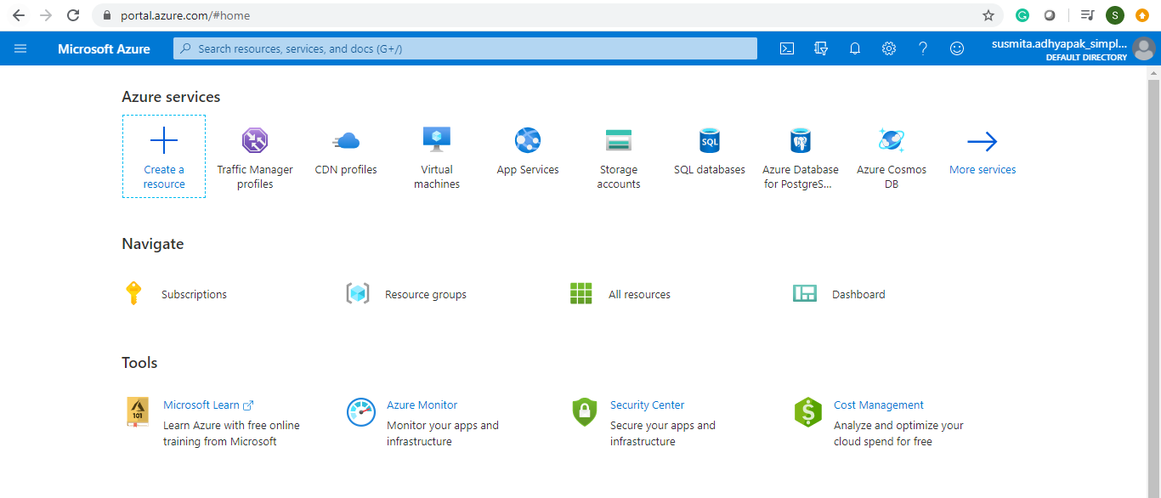

**Step 2:** Before creating the resources, make sure that you apply tags to resources so that you can keep a track of billing later on.

**Step 3:** To begin, create an Azure App Service Plan in Standard Tier

**Step 4:** Create an App Service (Web App) using the App Service Plan that you just created

Step 4.1: Click on **Create a resource**

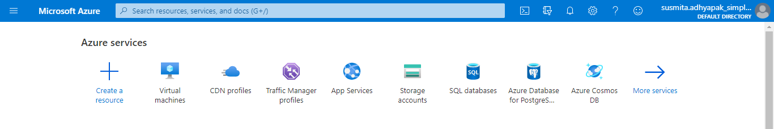

Step 4.2: Search for Web App and click on **Create**

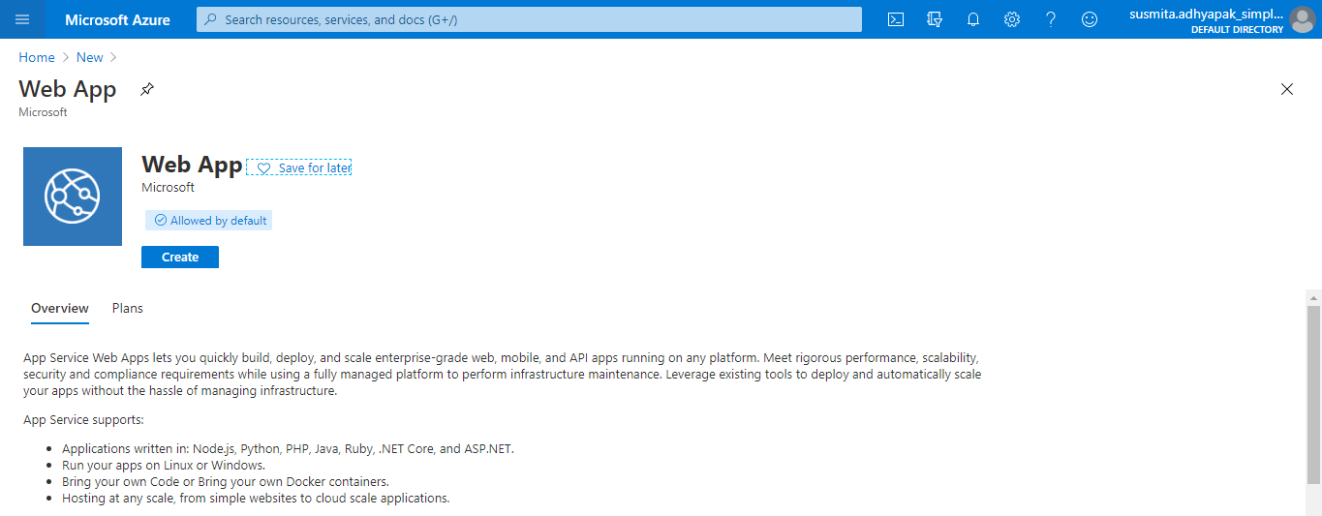

Step 4.3: Provide the basic information for the application

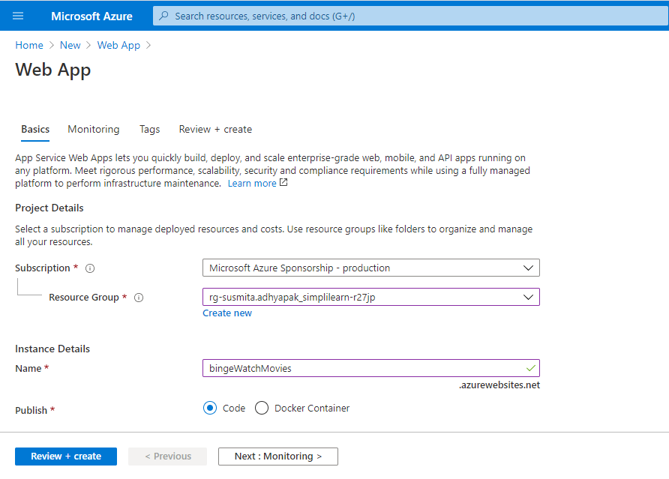

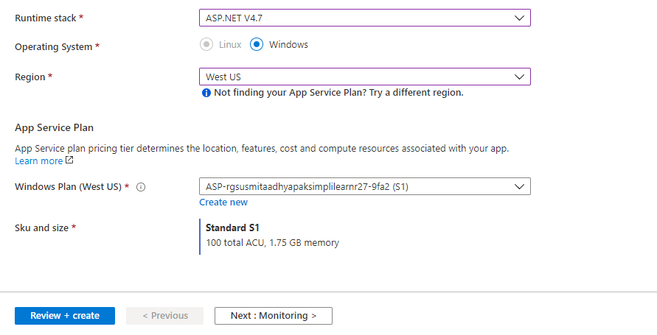

**Note:** Choose the runtime stack as ASP.NET V4.7 and the region as West US or West US 2

Step 4.4: In the Monitoring section, select **No** for **Enable Application Insights**

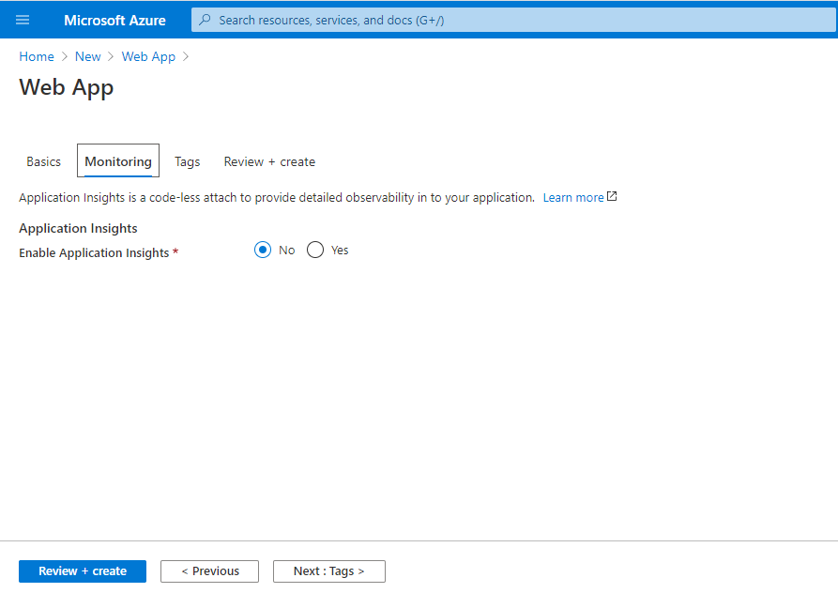

Step 4.5: Click on **Review and Create**

Step 4.6: Click on **Create**

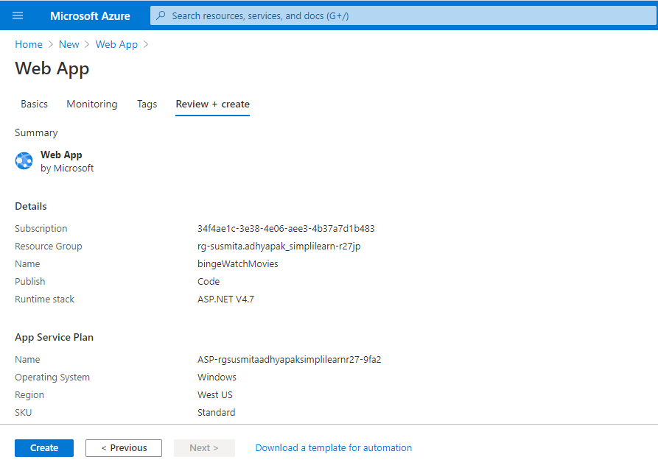

Step 4.7: This will create the Web App on Azure.

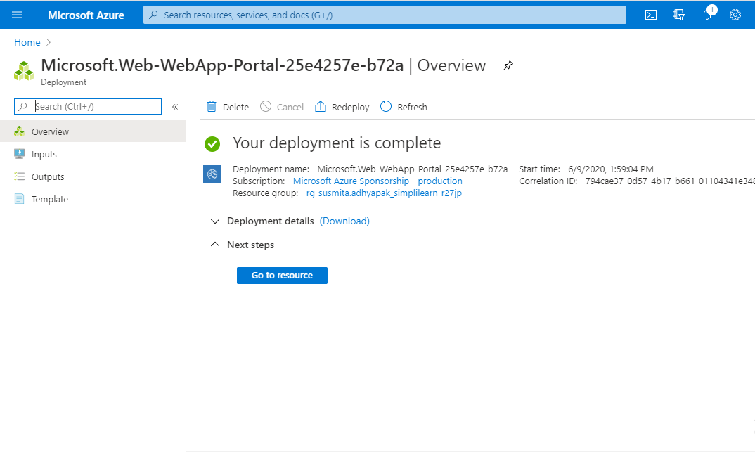

Step 4.8: You can click on **Go to resource** to get the overview of the created web app.

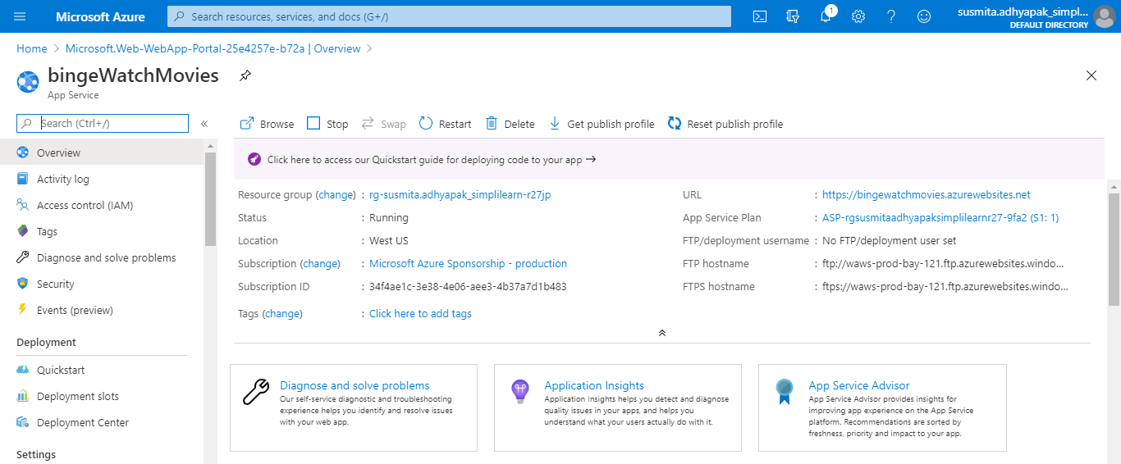

**Step 5:** Deploy your static web app to Azure App Service (Web App) using a method of your choice such as Visual Studio Code, GitHub, or FTP.

Step 5.1: Go to **Deployment Center**

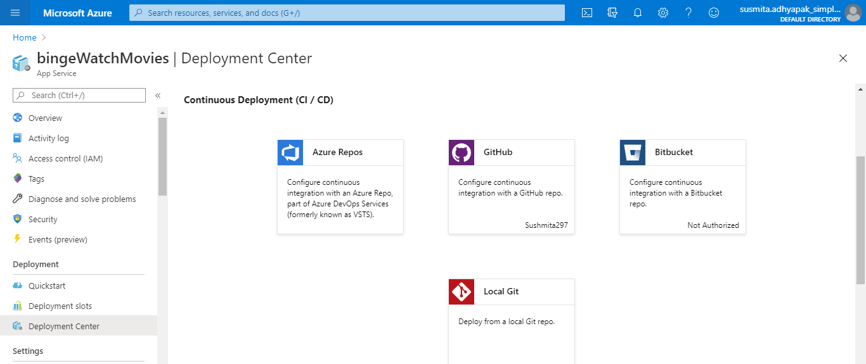

Step 5.2: Select GitHub

Step 5.3: Authorize your account

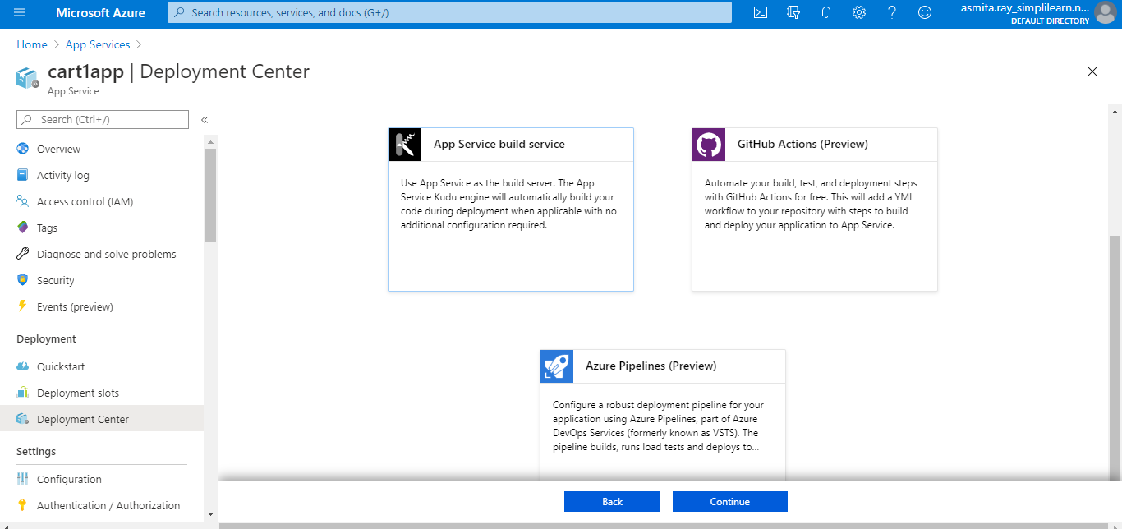

Step 5.4: Select the application files uploaded on GitHub and click **Continue**

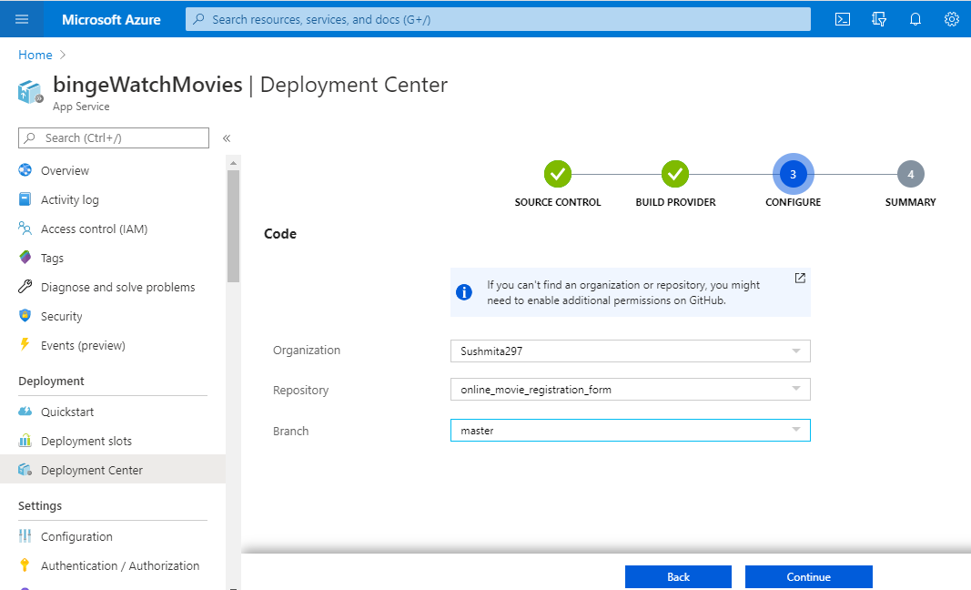

Step 5.5: Click **Finish**

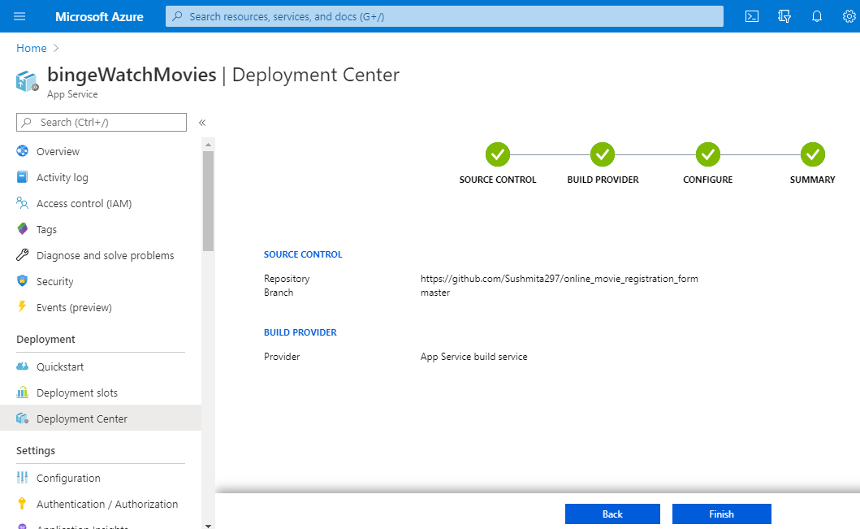

**Step 6:** Hit the web app endpoint to check if the application is online.

Step 6.1: Click on Overview of the web app

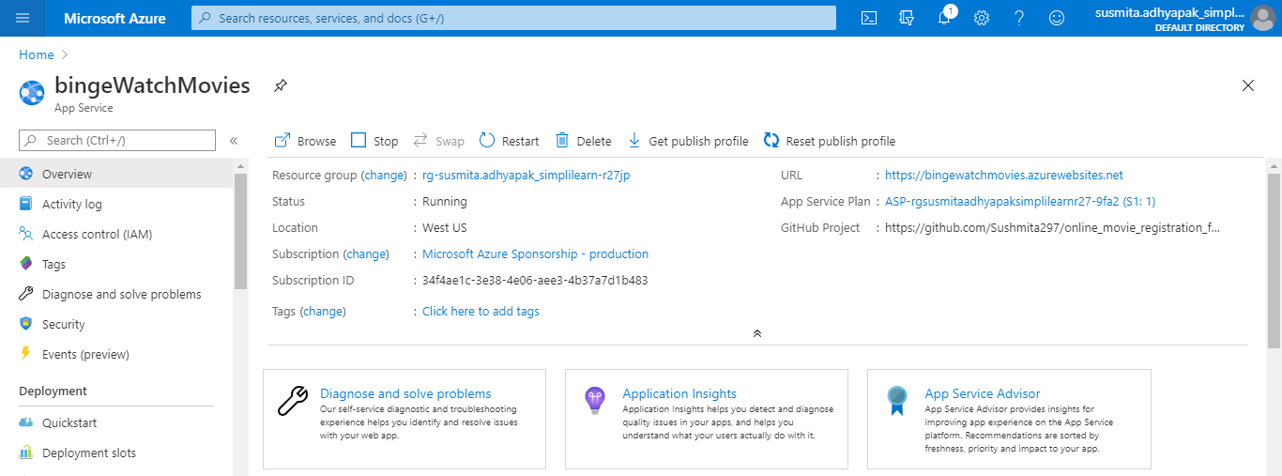

Step 6.2: Click the URL and you will get the application running

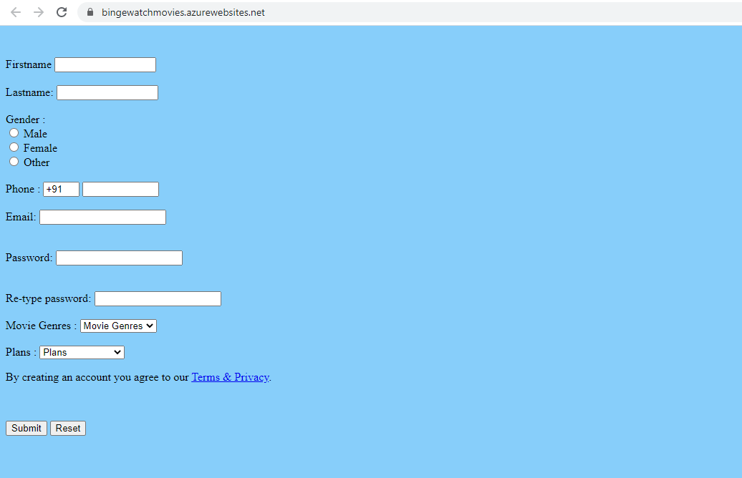

**Step 7:** Now create a CDN profile

Step 7.1: In the search window, search for CDN profiles

Step 7.2: Click on **Add**

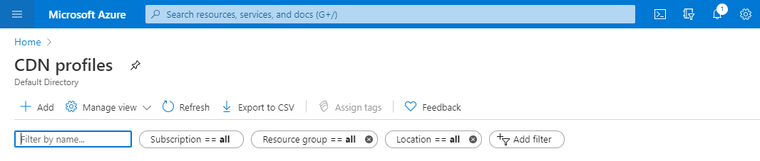

Step 7.3: Provide the information to create the CDN and click **Create**

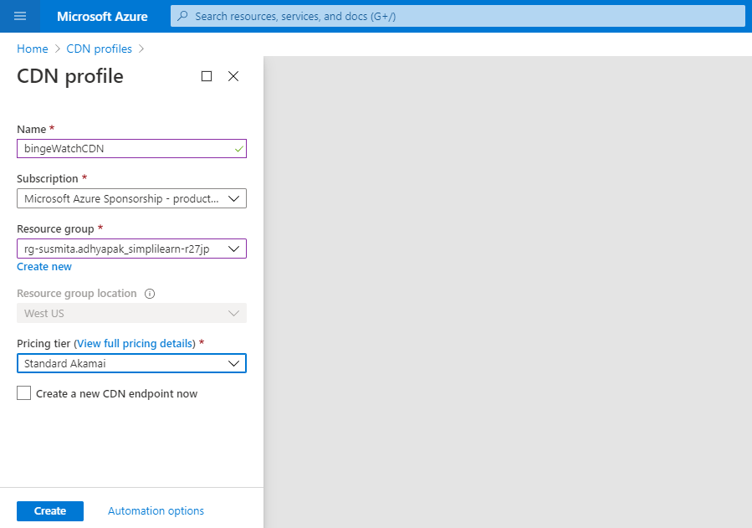

**Step 8:** Use CDN profile to create an endpoint

Step 8.1: Go to the created CDN

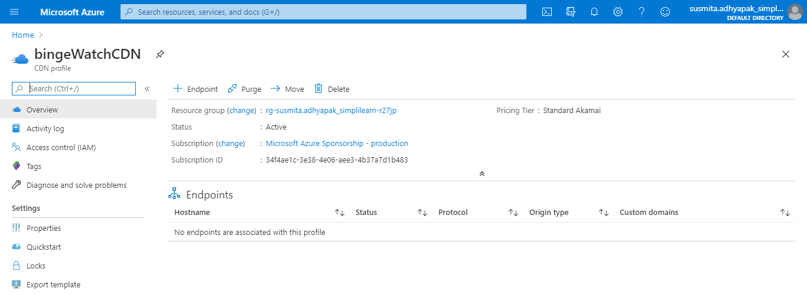

Step 8.2: Click on Endpoint

Step 8.3: Provide the basic information about the endpoint and click on **Add**

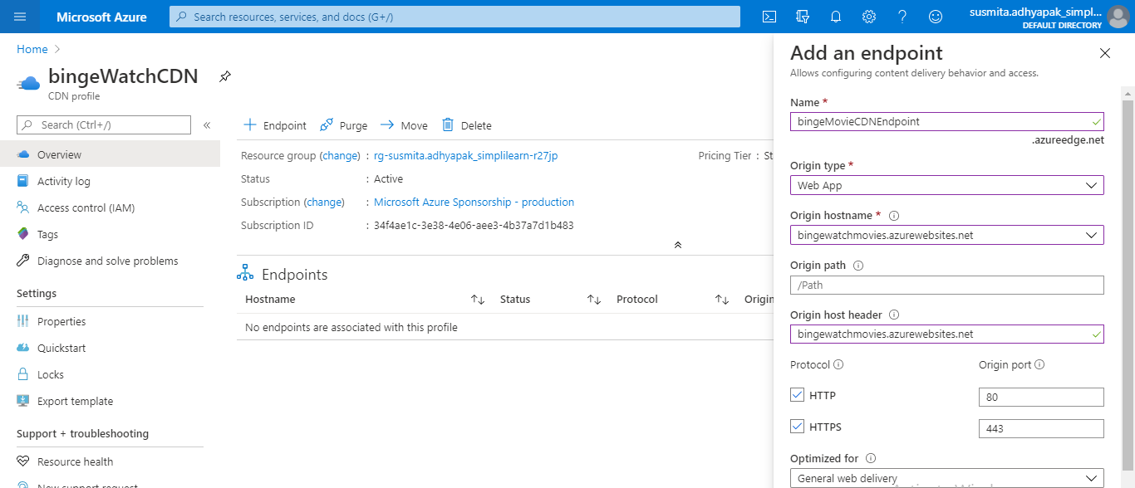

Step 8.4: Go to the created CDN endpoint and click on **Origin hostname**

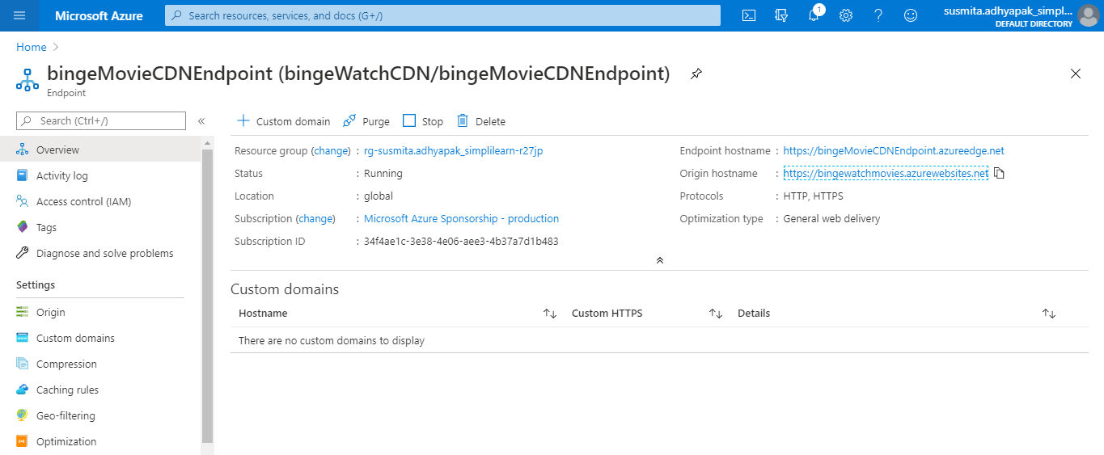

Step 8.5: Your application is running.



**Step 9:** Repeat steps 2 to 7 to create multiple deployments of your application in different regions so that you can meet the global traffic demand

**Step 10:** To make sure that traffic coming from different parts of the world is load balanced at DNS level, create a Traffic Manager Profile

Step 10.1: In the search window, search for Traffic Manager Profile and click on **Add** to create a new traffic manager profile

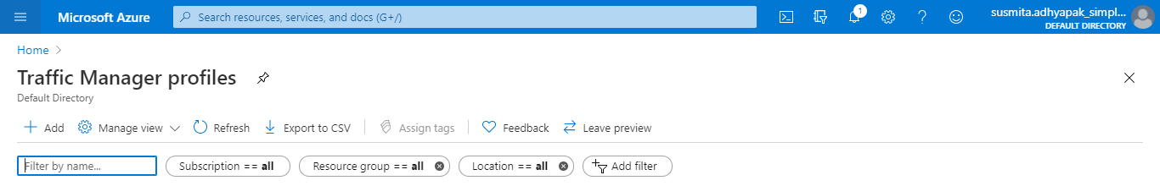

Step 10.2: Provide the required information and click on **Create** to create the Traffic Manager Profile

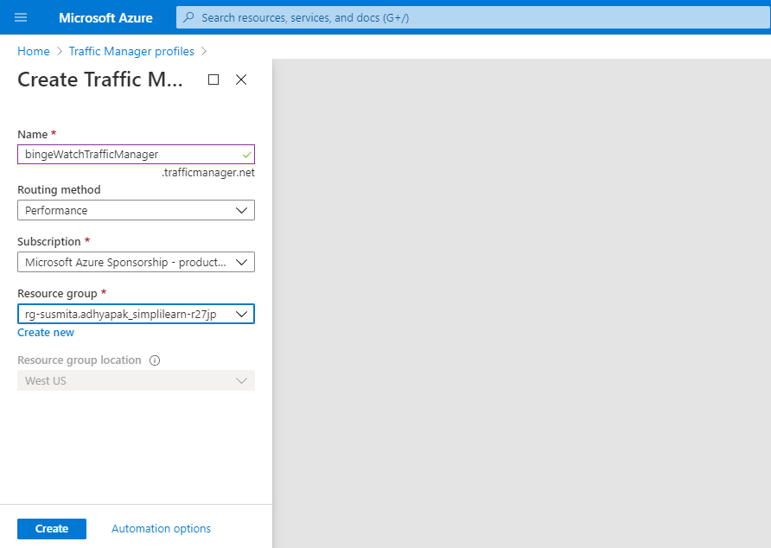

**Step 11:** Create endpoints in the traffic manager corresponding to each CDN endpoints that you have created.

Step 11.1: Go to the created Traffic Manager Profile

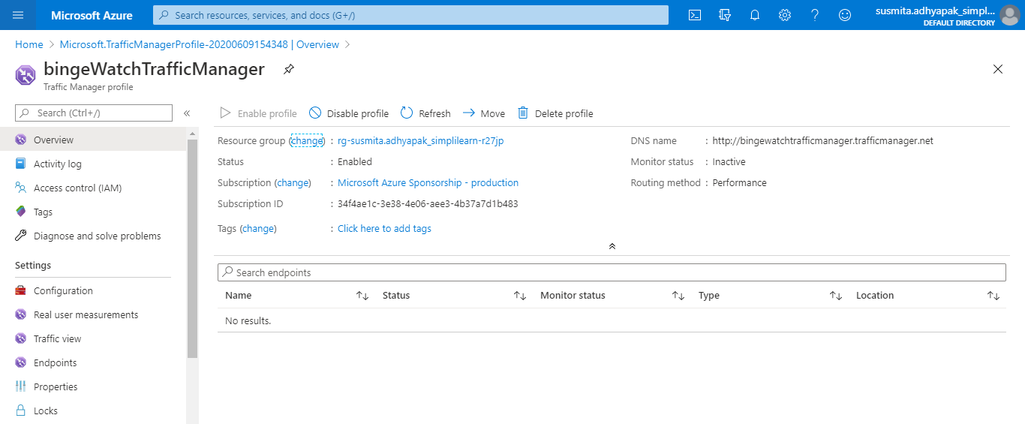

Step 11.2: Click on **Endpoints** and **Add** to add new endpoints

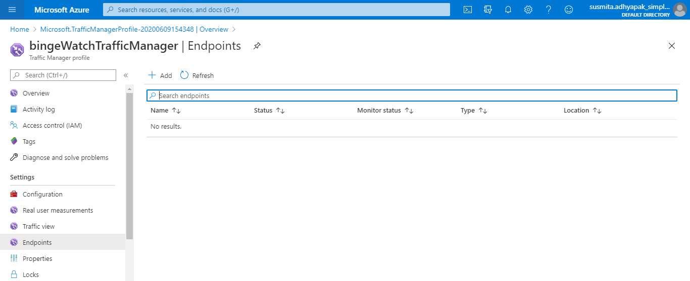

Step 11.3: Provide the required information and click on **Add**

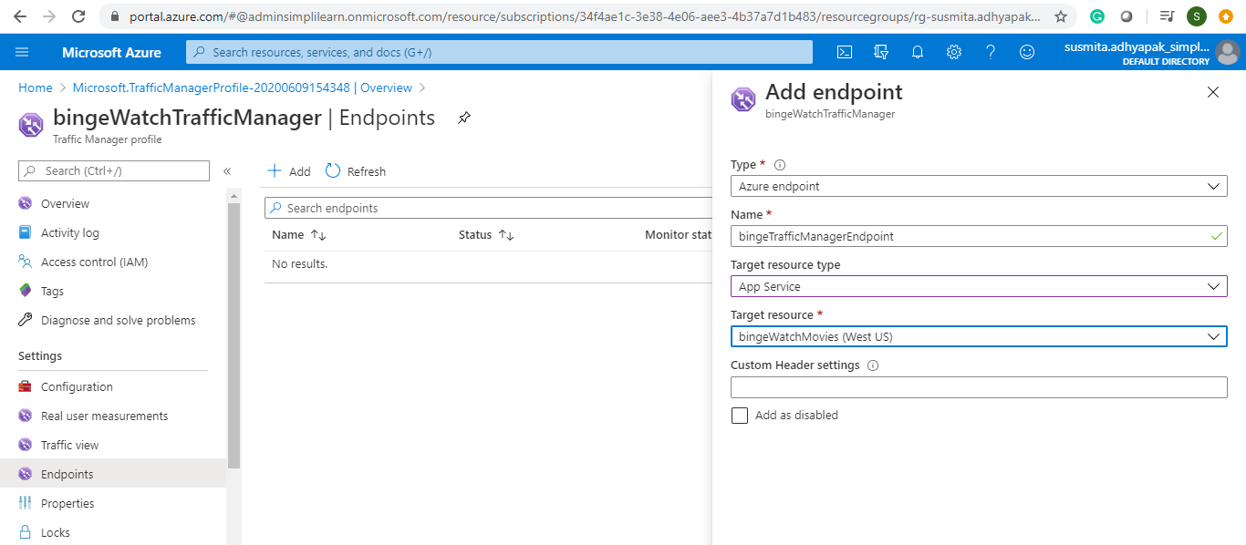

Step 11.4: Once the monitor status is online, copy the link of the DNS name and check whether the application is online or not



**Step 12:** Optionally, if you want to add the application in your own domain, you can configure the traffic manager to point to a custom domain.

**Step 13:** As good practice, follow the principle of least privilege so that you give access to the services that need to be accessed within the Azure portal

**Azure:**

Approach 2:

**Step 1:** Log into the Azure portal



**Step 2:** Before creating the resources, make sure that you apply tags to resources so that you can keep a track of billing later on.

**Step 3:** To begin, create an Azure VM.

Step 3.1: Search for Virtual Machines and click on **Add**

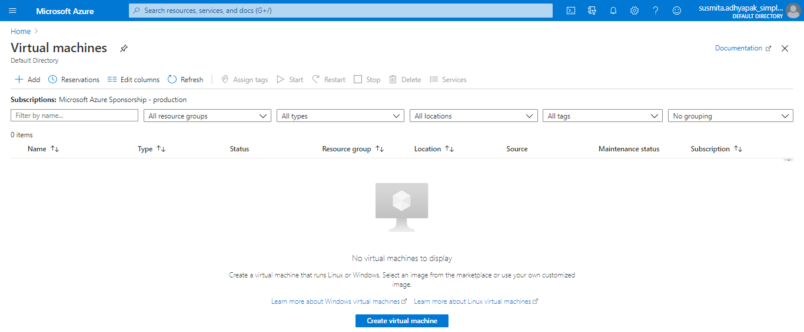

Step 3.2: Provide basic information about VM

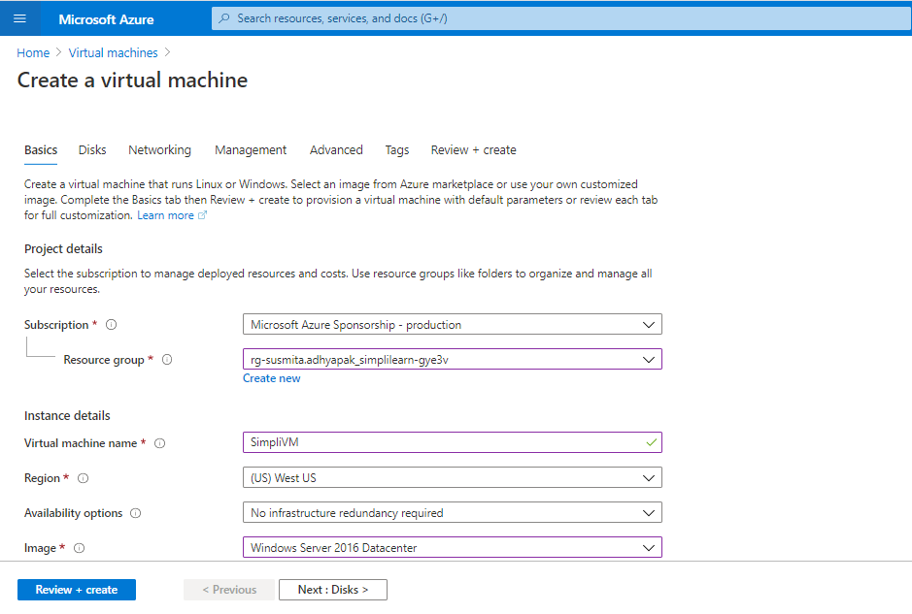

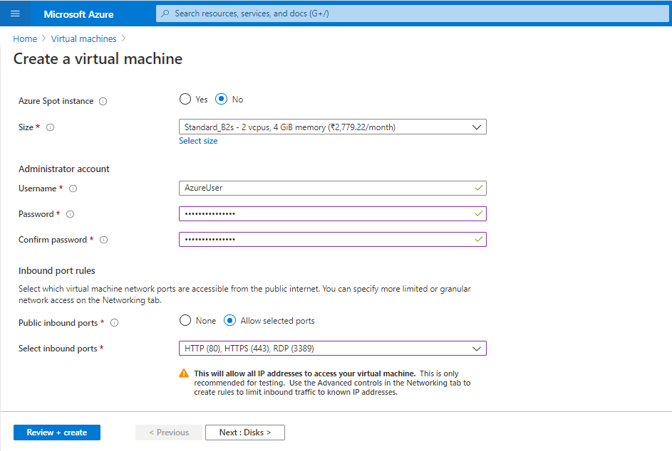

Step 3.3: In the Disks section, provide the required information

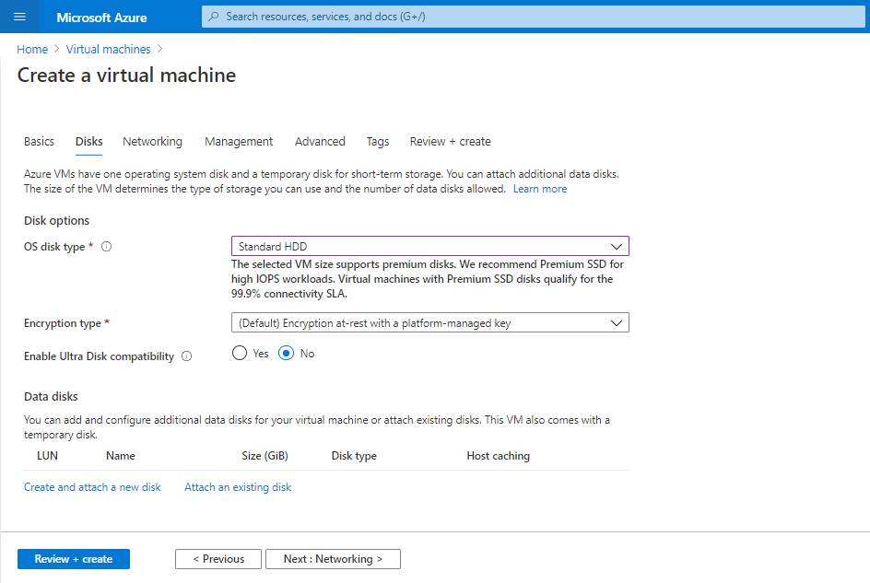

Step 3.4: In the Management section, turn off the Boot diagnostics

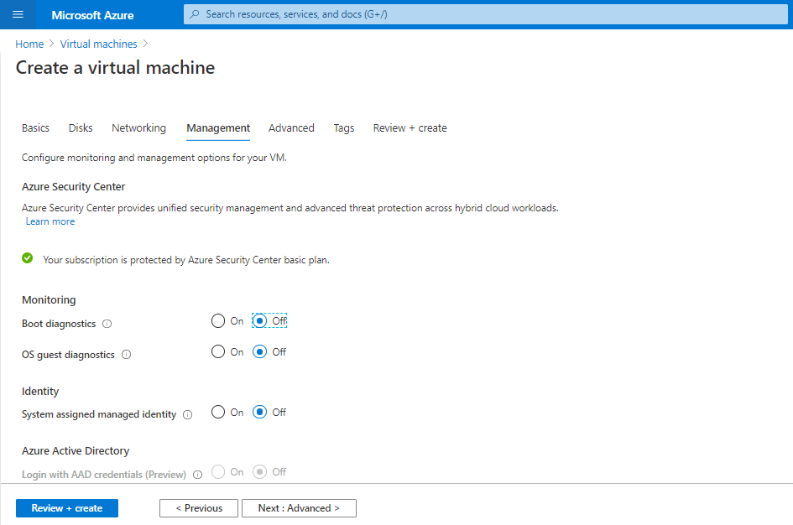

Step 3.4: Click on **Review and Create**

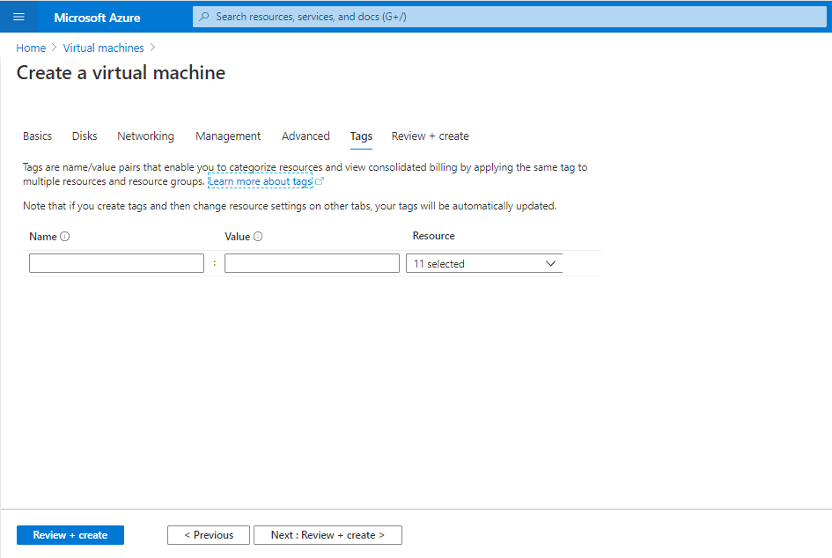

Step 3.5: Click on **Create**

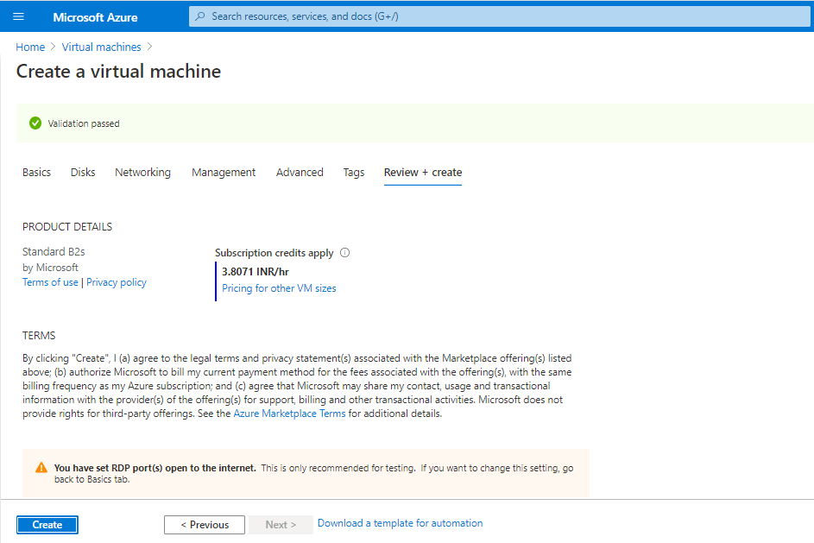

Step 3.6: Your VM will get deployed.

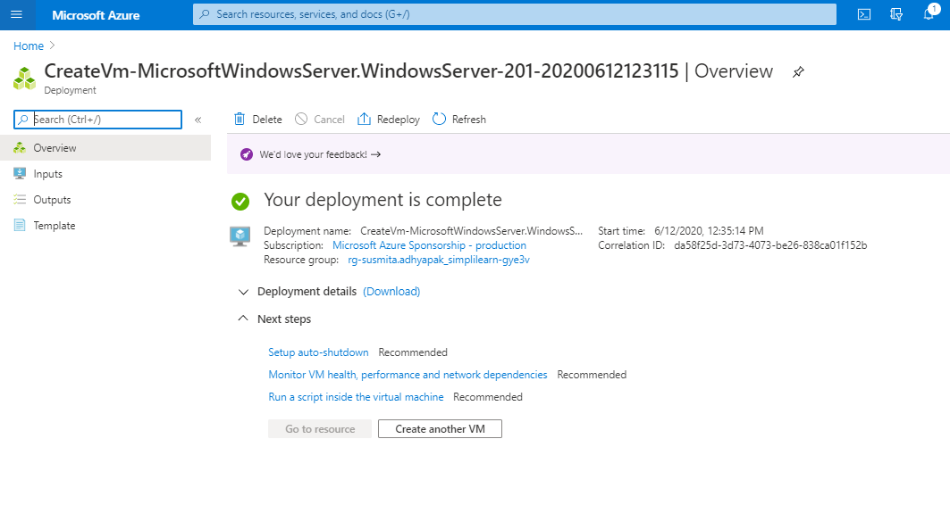

**Step 4:** Make sure you have inbound traffic on port 80 and port 443 open.

**Step 5:** Make sure port 445 is opened on your VMs so that teammates can use common file share to access and share files if needed.

**Step 6:** Log into Azure VM and spin up a web server of your choice on port 80.

Step 6.1: Click on **Connect** and select **RDP**

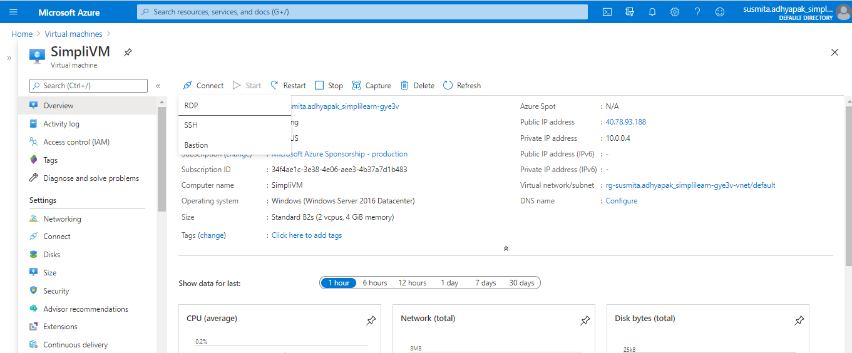

Step 6.2: Click on **Download RDP file.** It will download the created VM in your system.

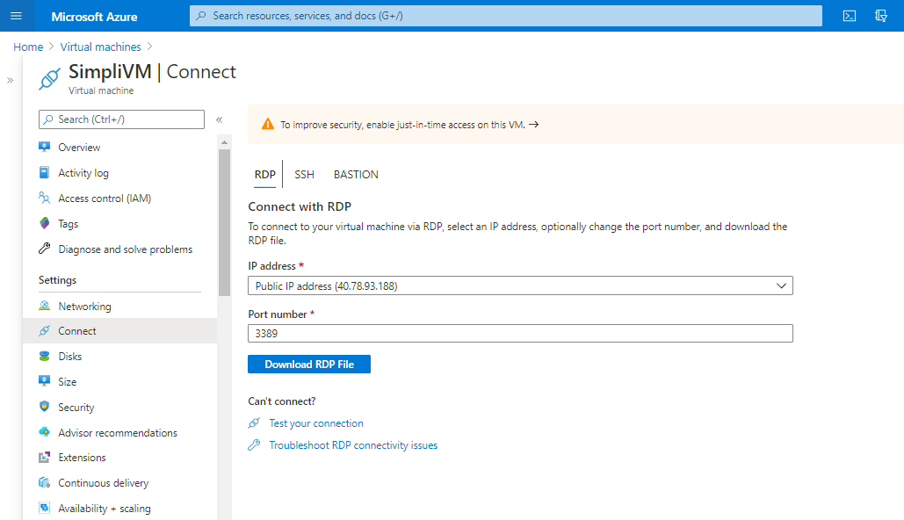

Step 6.3: Open the downloaded VM. Click on **Connect**

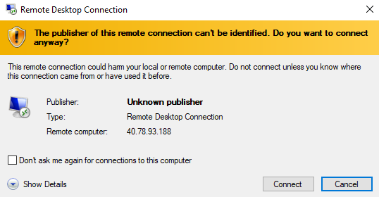

Step 6.4: Enter the credentials to login into VM and click on **OK**

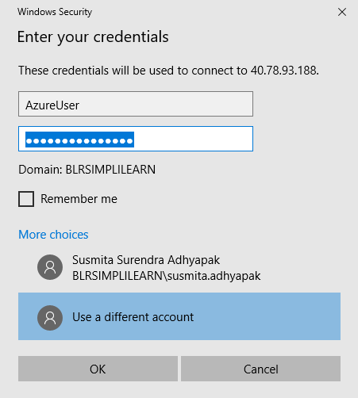

Step 6.5: This will open the VM in your system.



**Step 7:** Deploy your application on the web server that you have created within the virtual machine

Step 7.1: In the portal, select the VM and in the overview of the VM, use the **Click to copy** button to the right of the IP address to copy and paste it into a browser tab. The default IIS welcome page will open, and should look like this:

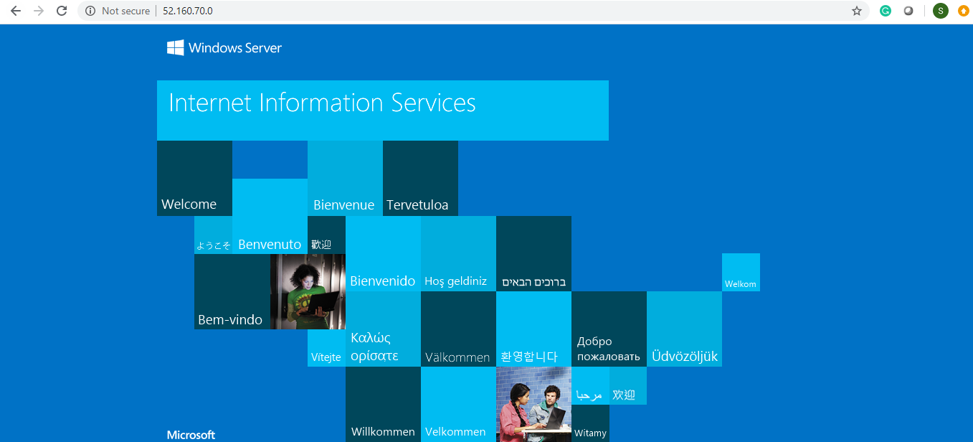

Step 7.2: Open the powershell and type the following command:

*Install-WindowsFeature -name Web-Server -IncludeManagementTools*

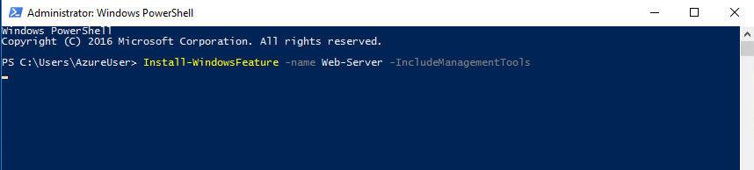

Step 7.3: The above command will create an inetpub folder in your C drive. Go to C:\inetpub\wwwroot and copy-paste the index.html file of your application which you want to deploy here:

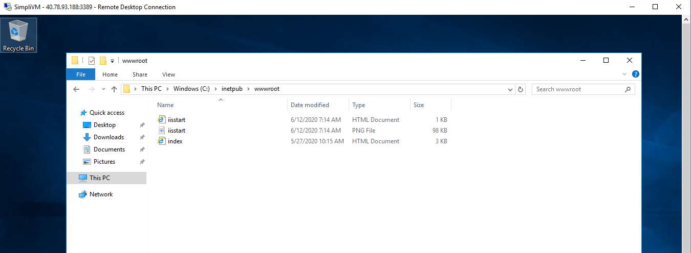

Step 7.4: Copy and paste the public IP address of the created VM in the browser and you will get the output

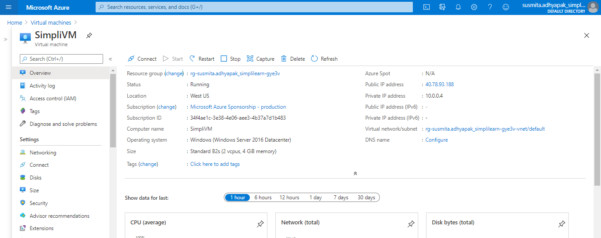

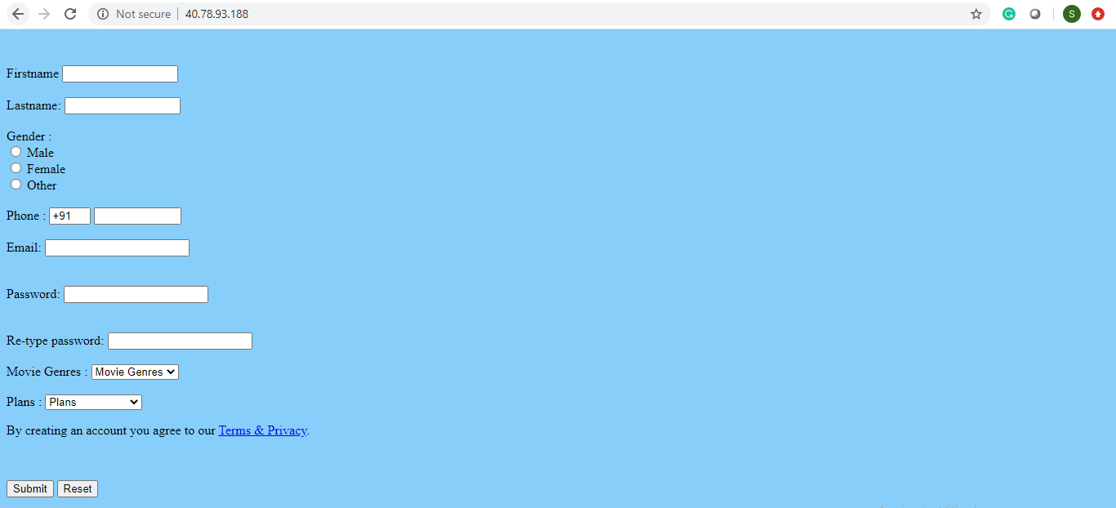

**Step 8:** Repeat steps 2 to 6 to create multiple deployments of your application in different regions so that you can meet the global traffic demand

**Step 9:** To make sure that traffic coming from different parts of the world is load balanced at DNS level, create a Traffic Manager Profile.

Step 9.1: Click on the Public IP address of the created VM

Step 9.2: Enter the DNS name and click on Save

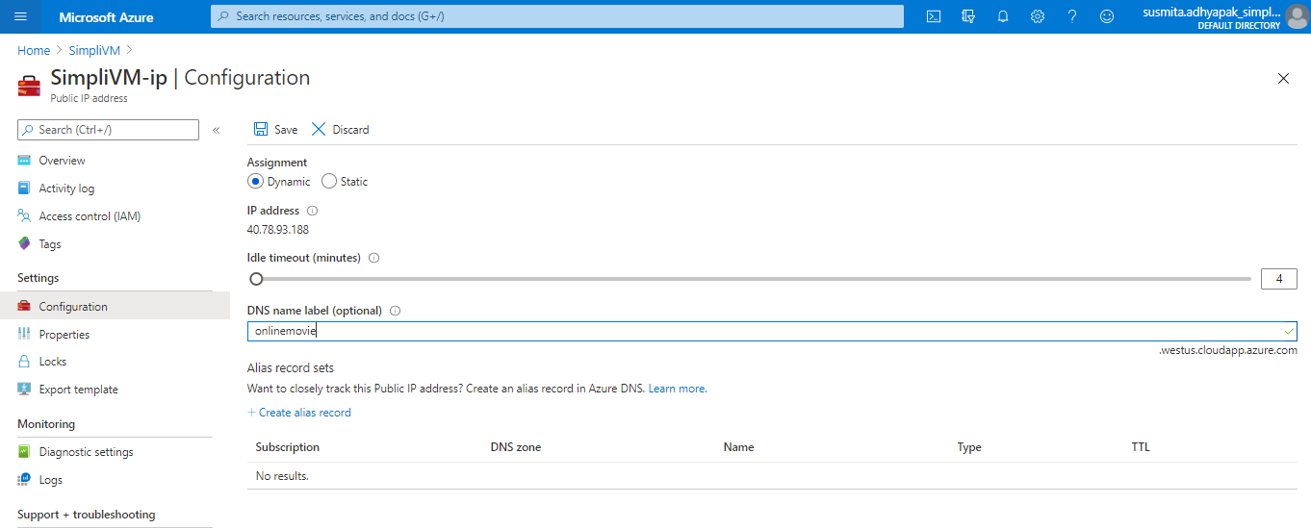

Step 9.3: In the search window, search for Traffic Manager Profile. Click on **Add** to create a new traffic manager profile



Step 10.2: Provide the required information and click on **Create** to create the Traffic Manager Profile

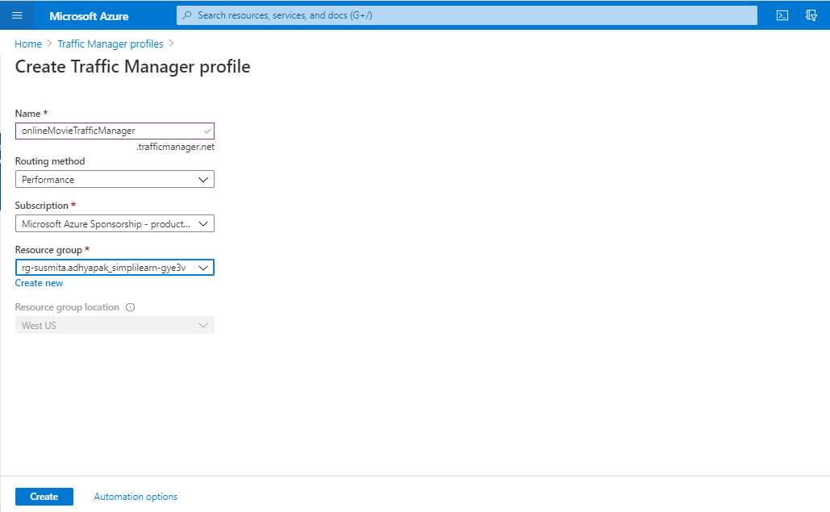

**Step 10:** Create endpoints in the traffic manager corresponding to public IP of each virtual machine that you have created.

Step 10.1: Go to the created Traffic Manager Profile

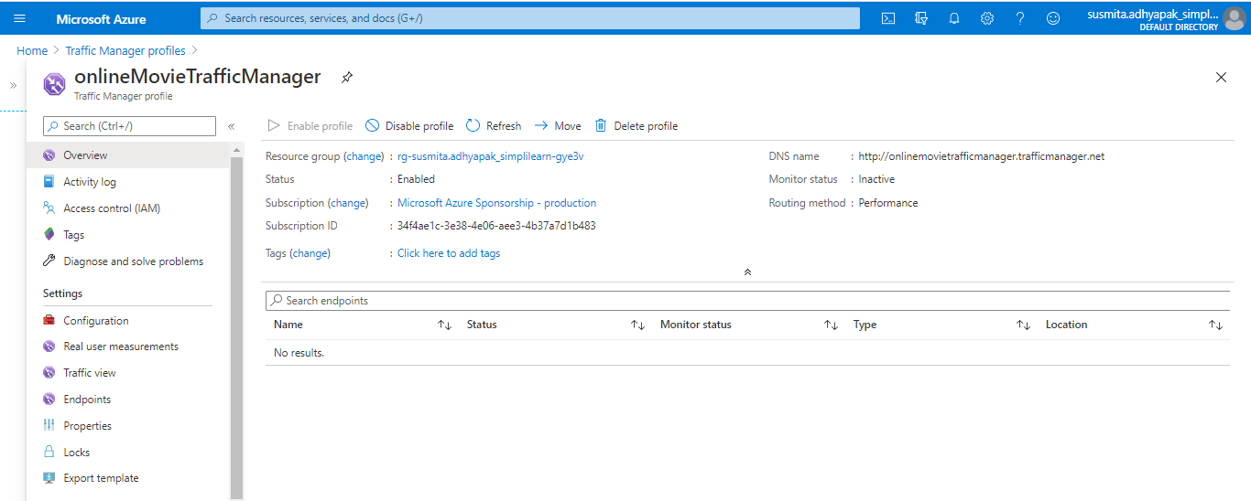

Step 10.2: Click on **Endpoints**. Click on **Add** to add new endpoints

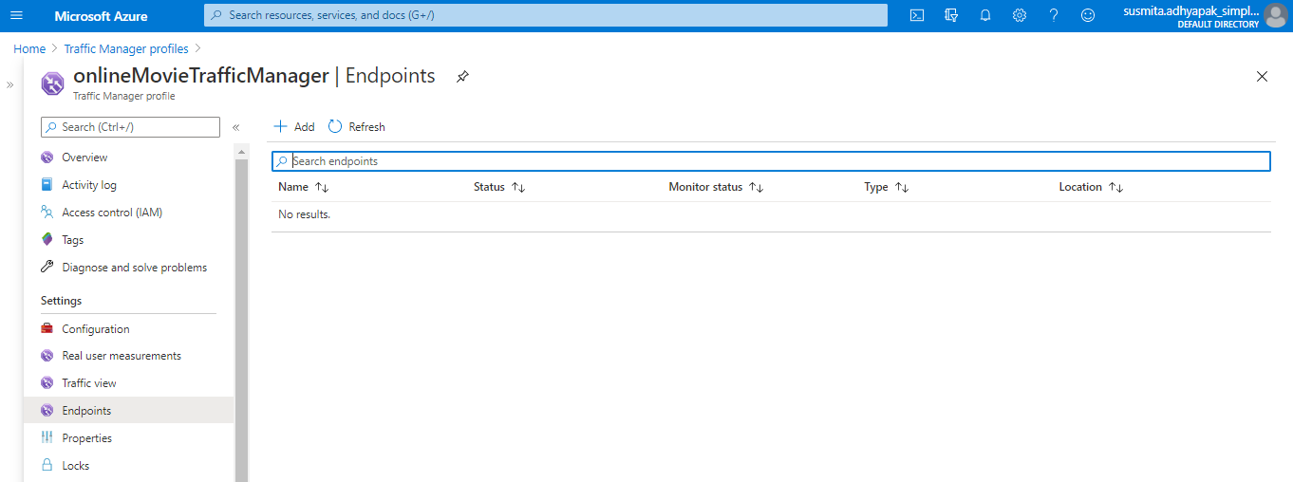

Step 10.3: Provide the required information and click on **Add**

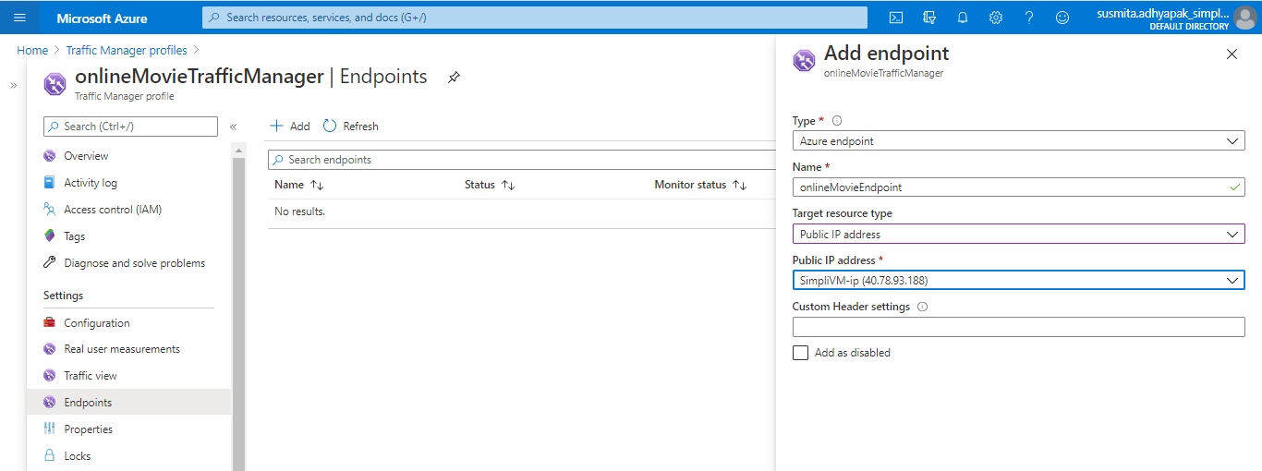

Step 10.4: Copy-paste the DNS name link in the web browser and you’ll get the output

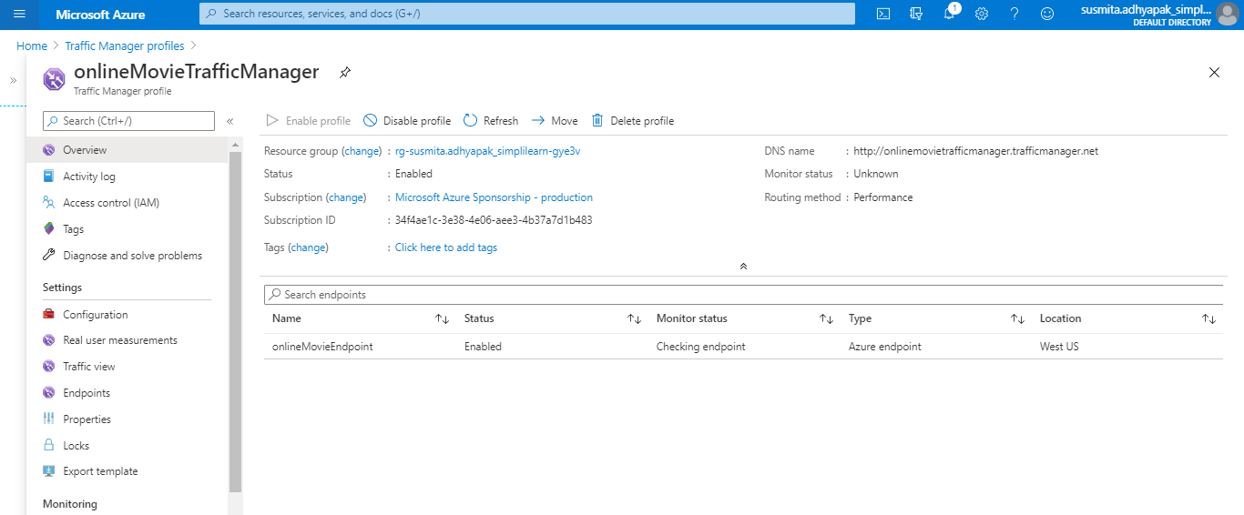



**Step 11:** Optionally, if you want to add in your own domain, you can configure the traffic manager to point to a custom domain.

**Step 12:** As good practice, follow the principle of least privilege so that you only give access to the services that need to be accessed within the Azure portal

**AWS:**

Approach 1:

**Step 1:** Log into the AWS console

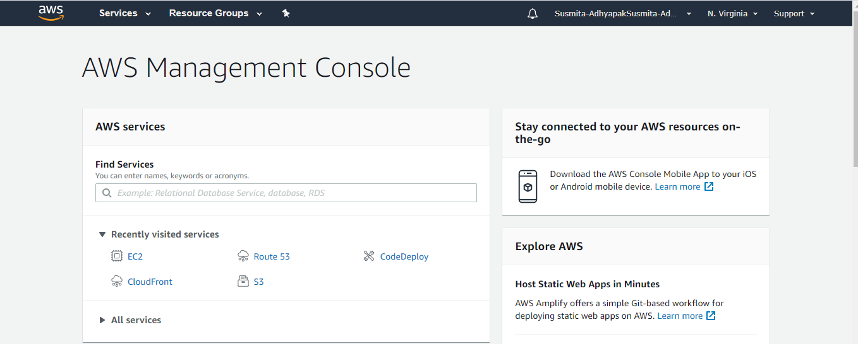

**Step 2:** Before creating the resources, make sure you apply cost allocation tags to resources so that you can keep a track of billing later on.

**Step 3:** To begin, create Route 53 and add a hosted zone if you have your own domain. This is an optional step to configure a custom domain for your web app.

**Step 4:** Create an S3 bucket

Step 4.1: In the search window, search for S3 service

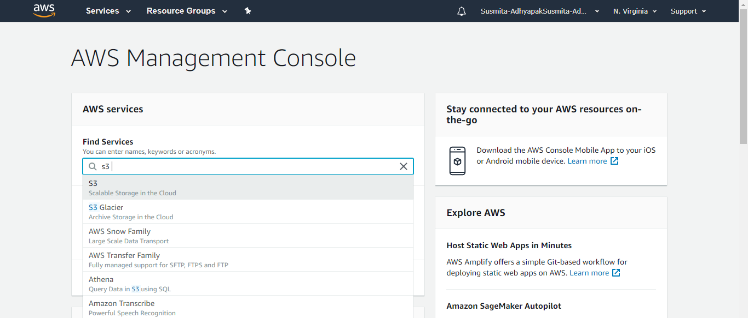

Step 4.2: Click on **Create bucket**

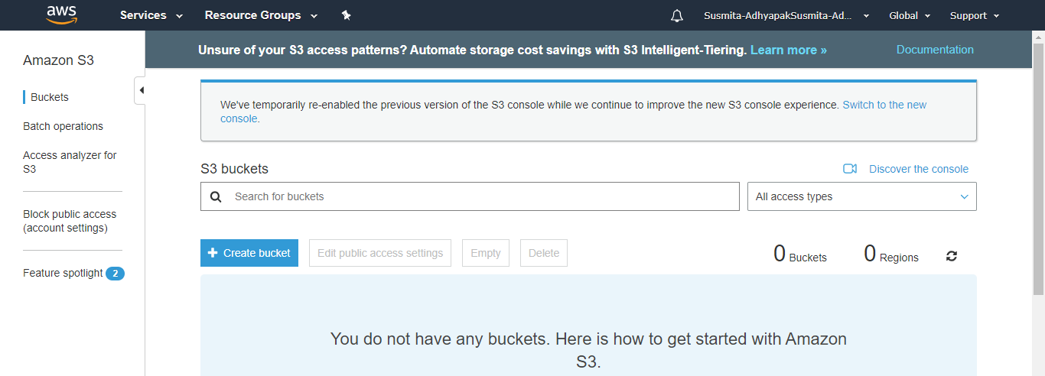

Step 4.3: Provide the bucket name, select the region, and click on **Next**

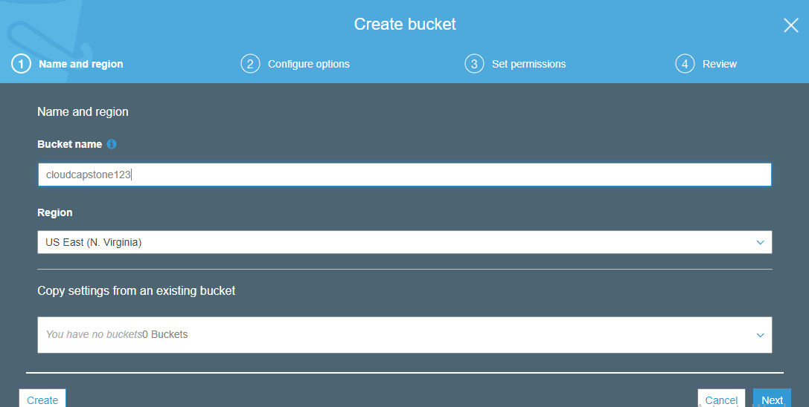

Step 4.4: In the Set permissions section, uncheck the box of Block all public access and acknowledge the terms and click on **Next**

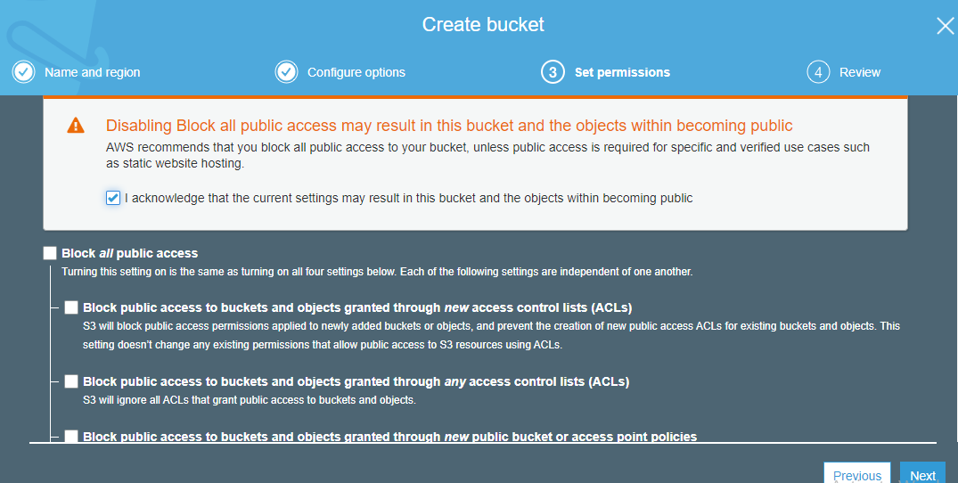

Step 4.5: Click on **Create bucket**

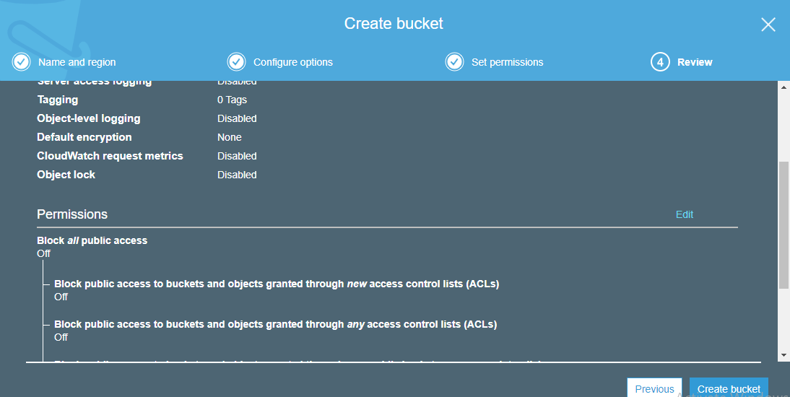

Step 4.6: The created bucket will be visible in the portal.

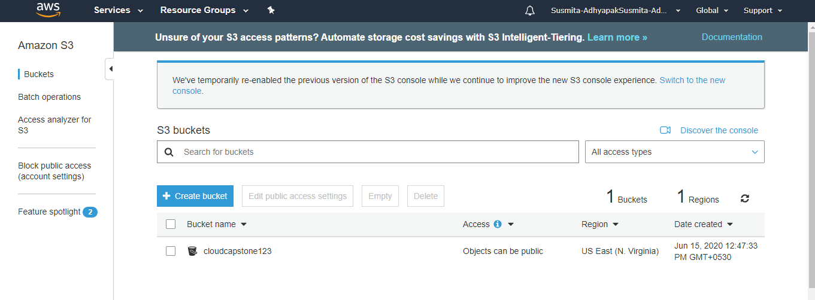

**Step 5:** In the properties of S3 bucket, configure the S3 bucket to enable Static website hosting

Step 5.1: Click on the created bucket

Step 5.2: Go to **Properties**

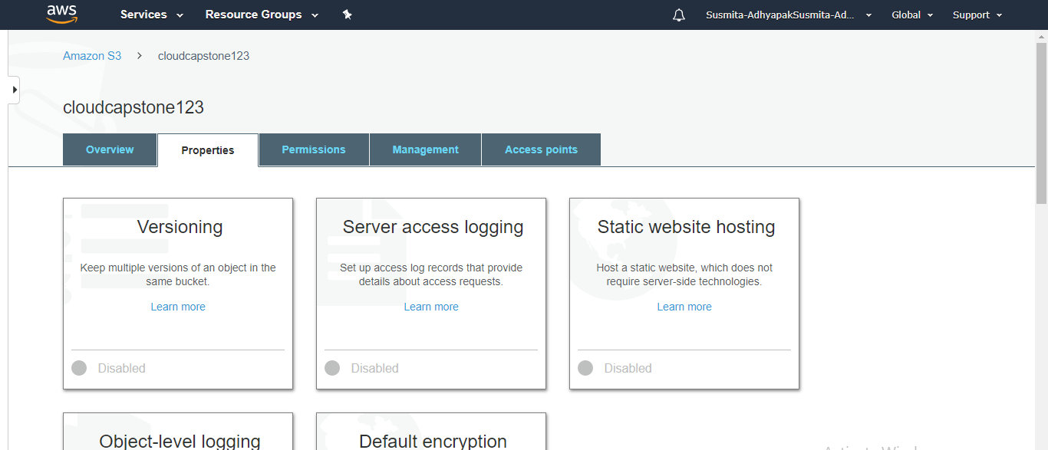

Step 5.3: Select Static web hosting

Step 5.4: Select **Use this bucket to host a website**, provide the required information and click on **Save**

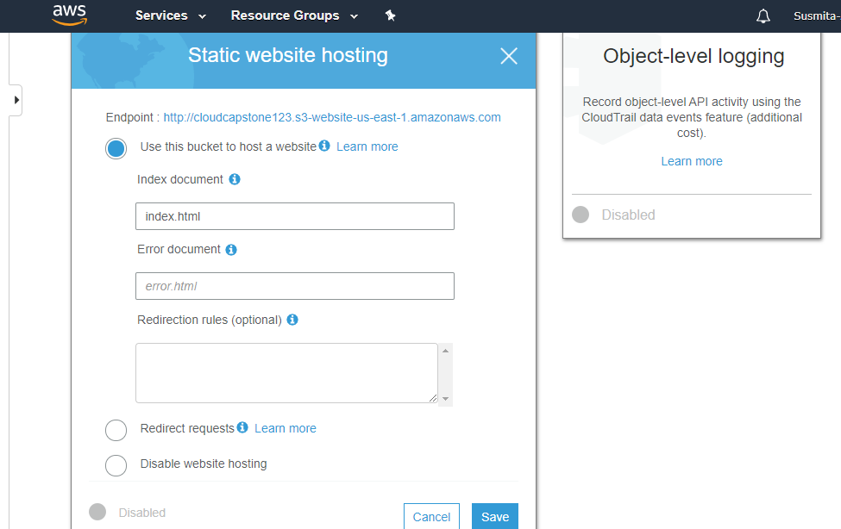

**Step 6:** Upload your static content (web app files) to the S3 bucket.

Step 6.1: Go to Overview tab of the created bucket and click on **Upload**

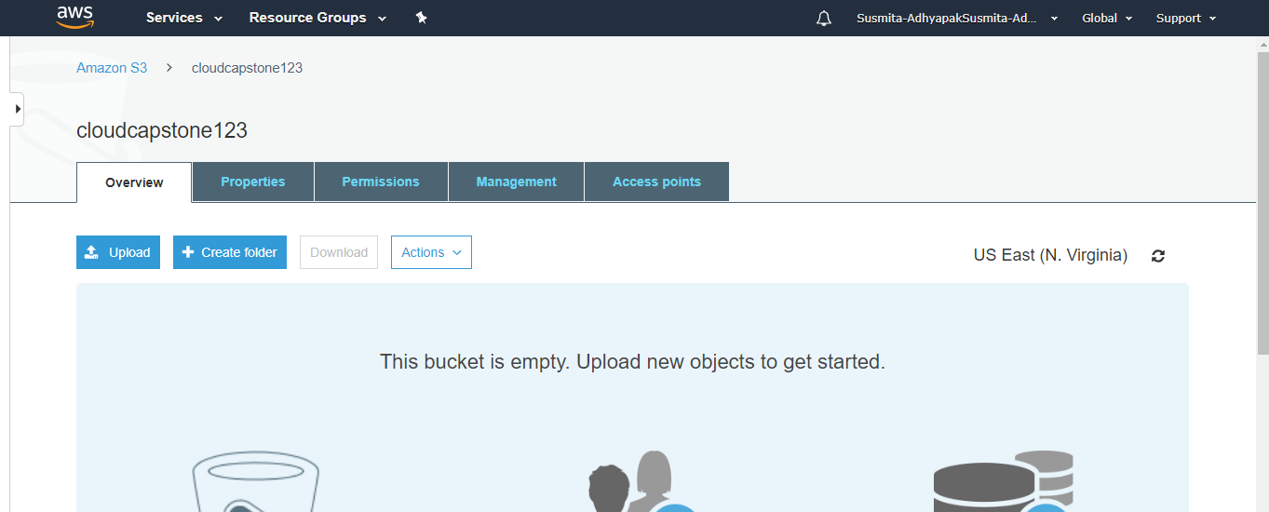

Step 6.2: Select the files of your application which you want to deploy and click on **Next** and click on **Upload**

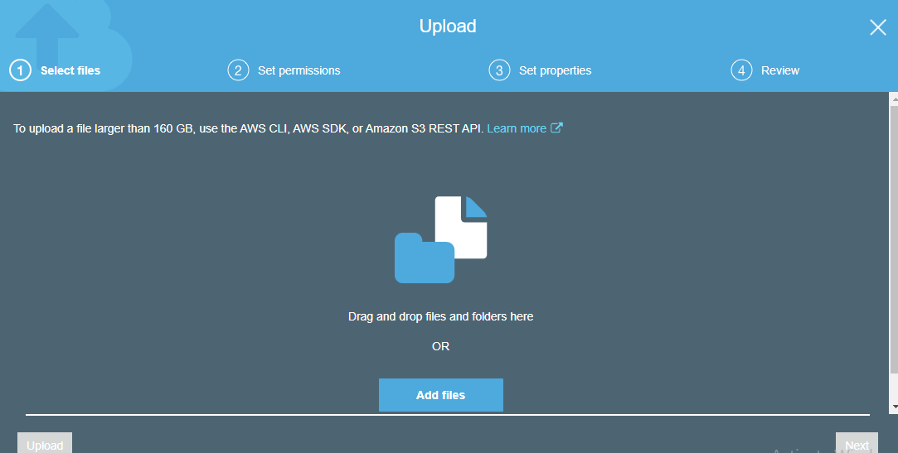

Step 6.3: This will add the files of your application in the S3 bucket.

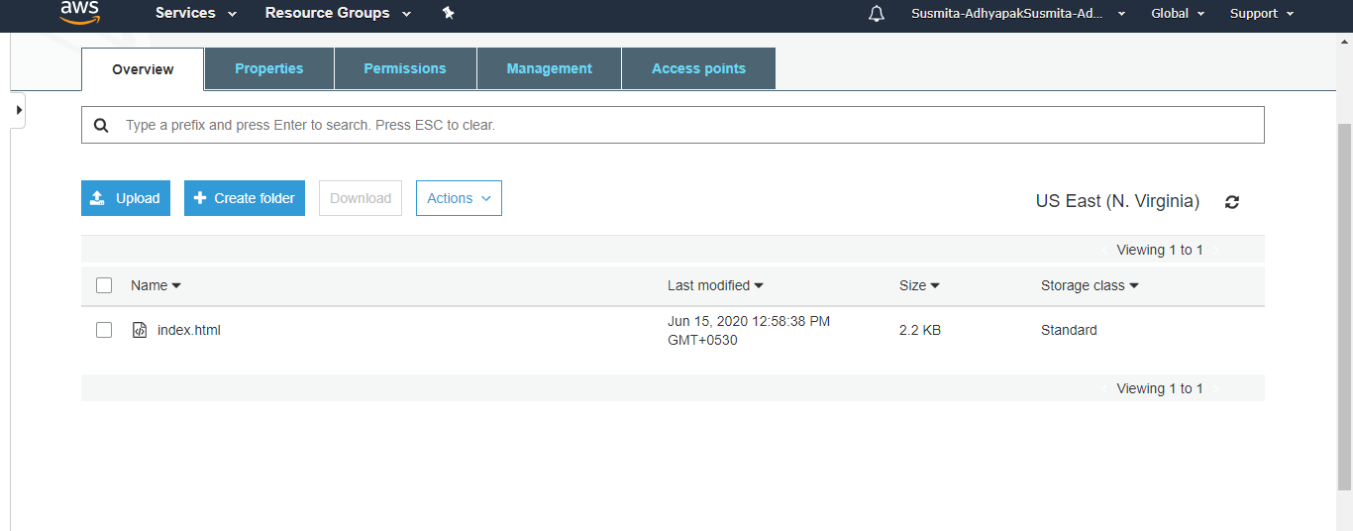

**Step 7:** Configure permissions in S3 and add below bucket policy to give read only access to the static web app endpoint

Step 7.1: Go to the **Permissions**, click on **Bucket policy**, add the following code there and click on **Save**

{

"Version":"2012-10-17",

"Statement":[

{

"Sid":"PublicRead", "Effect":"Allow", "Principal": "*", "Action":["s3:GetObject"], "Resource":["arn:aws:s3:::*cloudcapstone123*/*"] } ] }

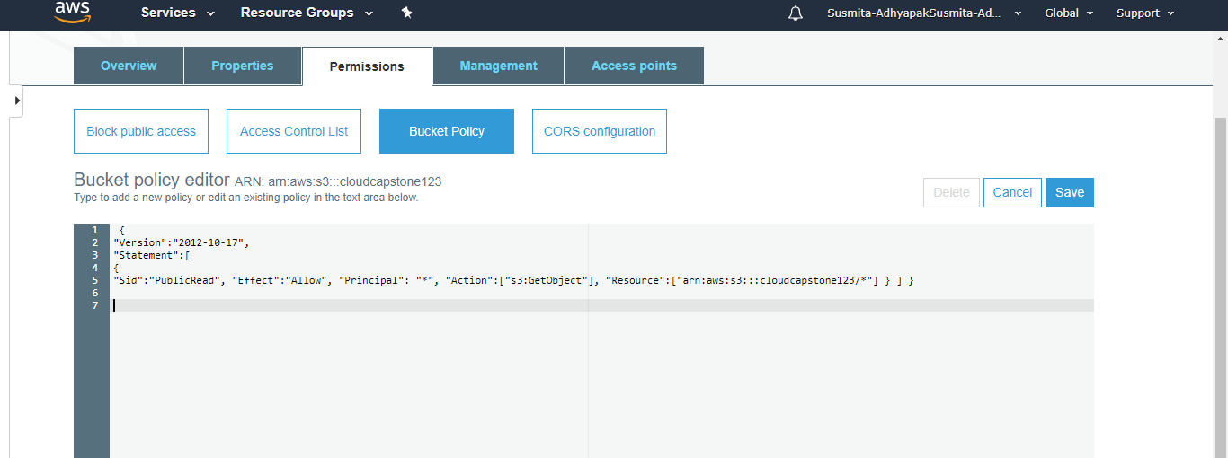

**Step 8:** Hit the web app endpoint to check if the application is online

Step 8.1: Click on the Overview tab of the created bucket and click on the uploaded file

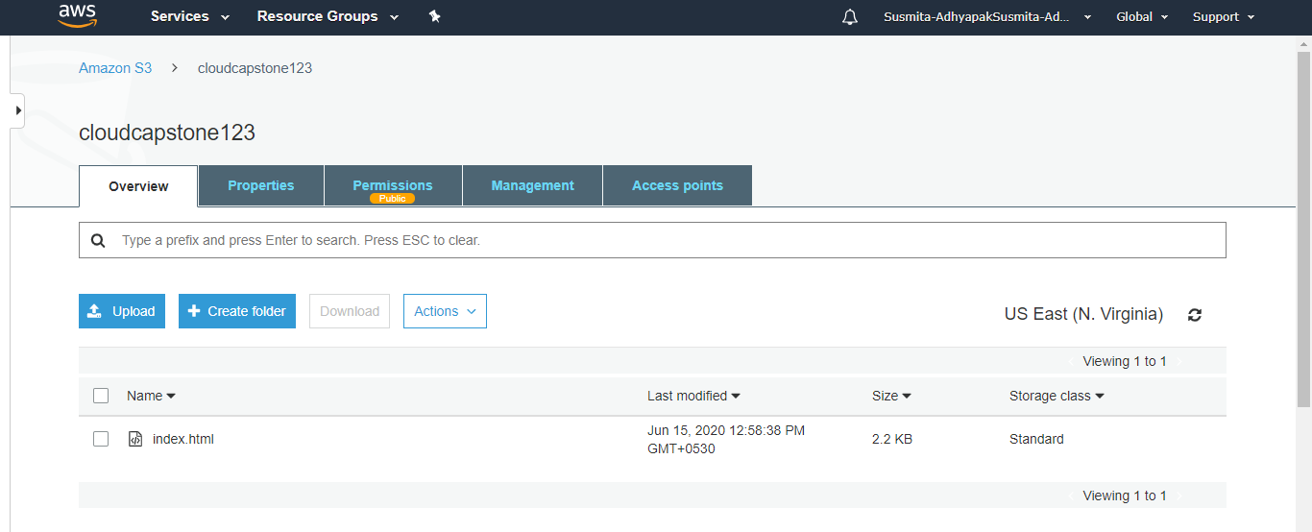

Step 8.2: Click on the **Object URL**

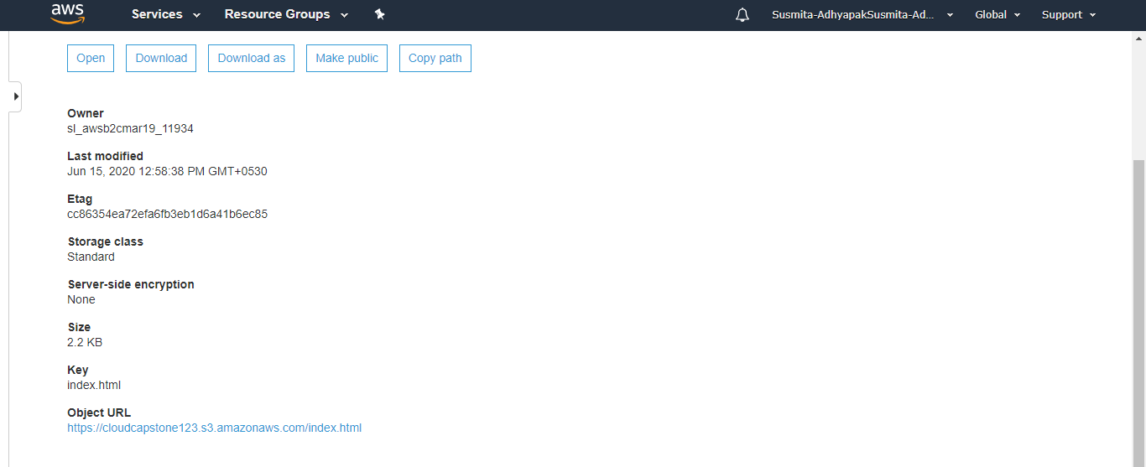

Step 8.3: Your application will start running.

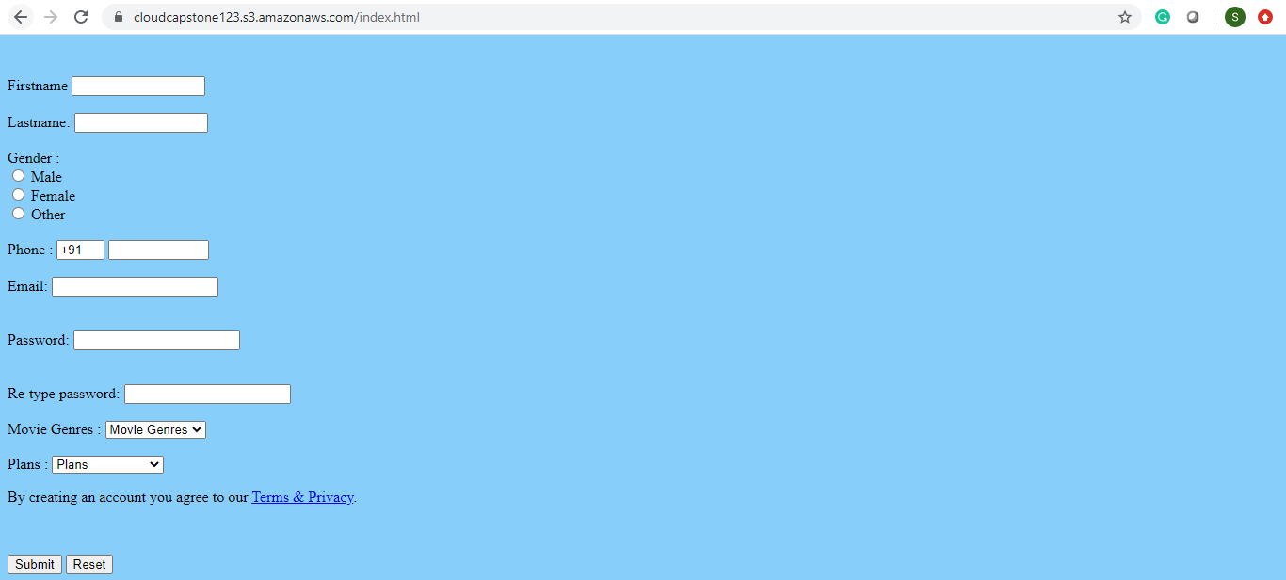

**Step 9:** Now create a CloudFront distribution corresponding to the static web app endpoint

Step 9.1: Go to services and search for CloudFront

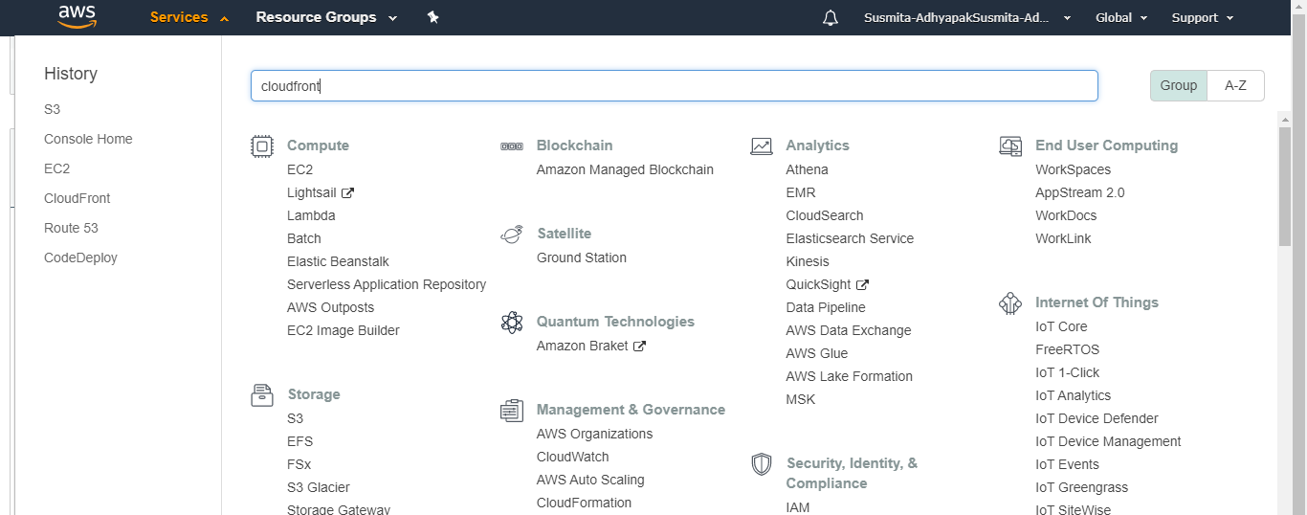

Step 9.2: Click on **Create Distribution**

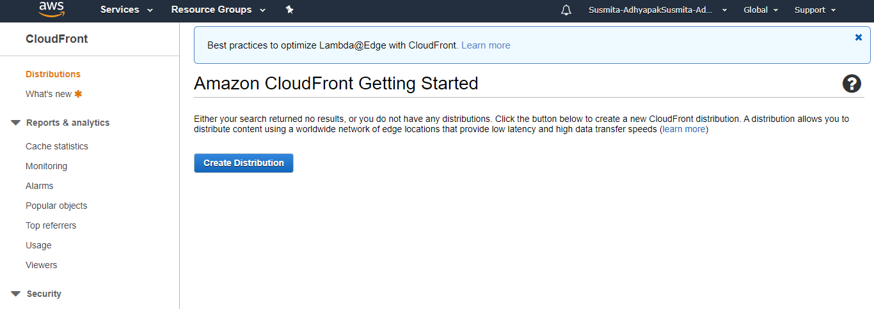

Step 9.3: Select a delivery method for your content as Web and click on Get Started

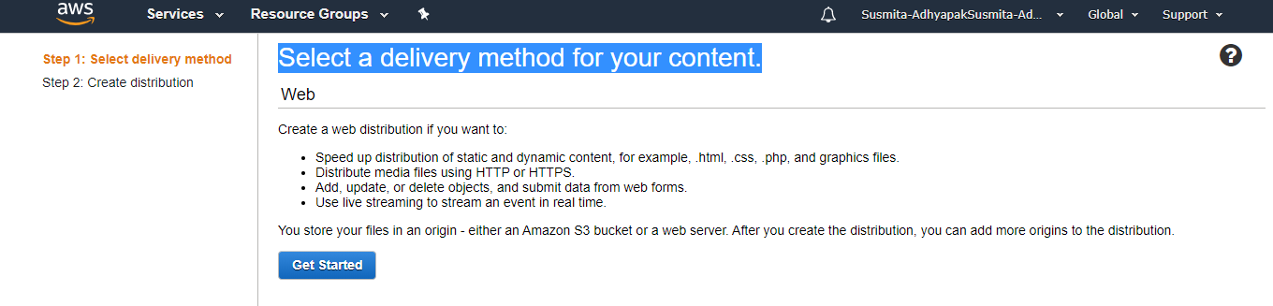

Step 9.4: Provide the Origin Domain Name and Origin ID

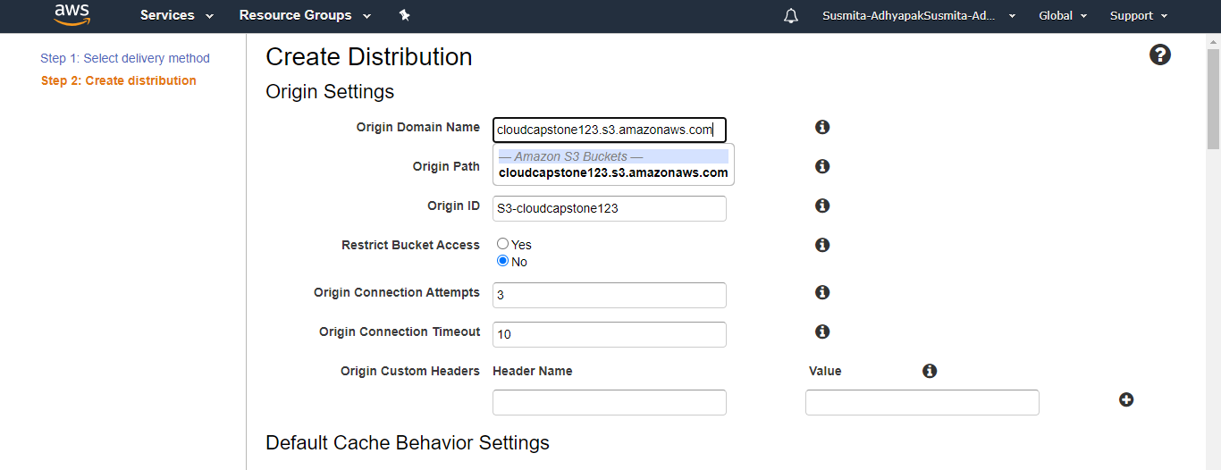

Step 9.5: Keep all the values as default and click on **Create Distribution**

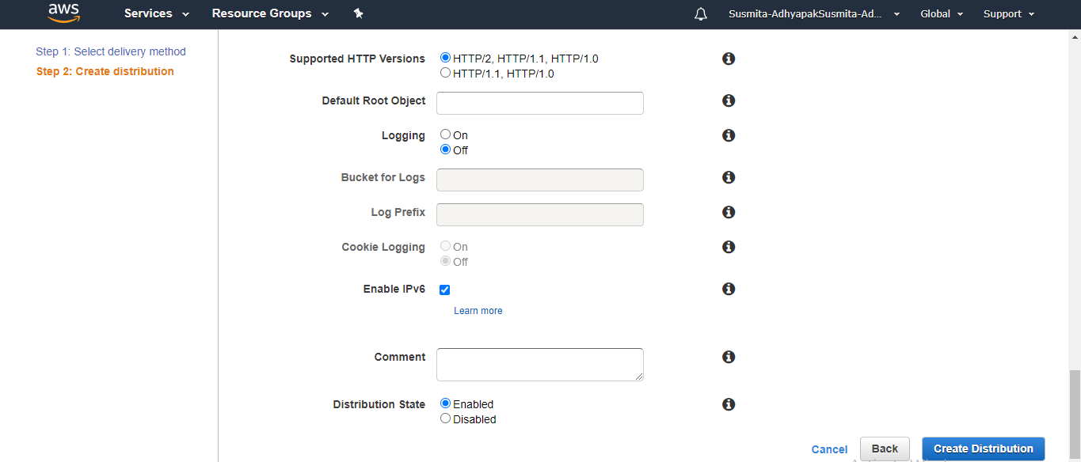

Step 9.6: These steps will create your CloudFront distribution.

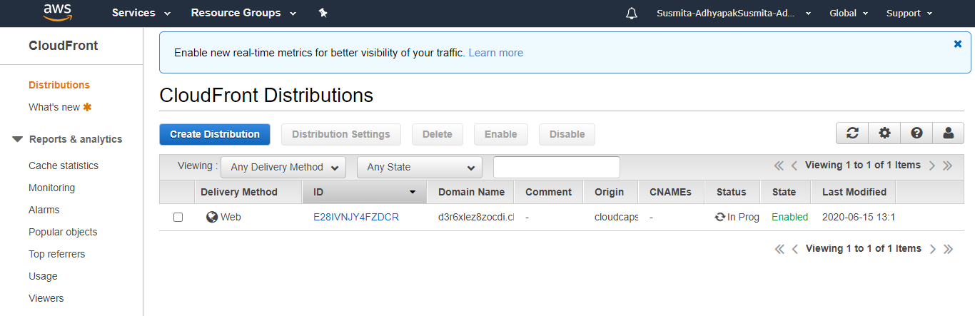

**Step 10:** Configure the CloudFront distribution to point to your domain by editing the configuration and adding the domain name in Alternate Domain Name field

Step 10.1: Once the CloudFront service get deployed, create a new file of .html extension in your system and copy the following content in it

<html>

<head>My CloudFront Test</head>

<body>

<p>My text content goes here.</p>

<p><img src=https://d111111abcdef8.cloudfront.net/.html alt="my test image"/>

</body>

</html>

Step 10.2: Upload the same file in the created S3 bucket

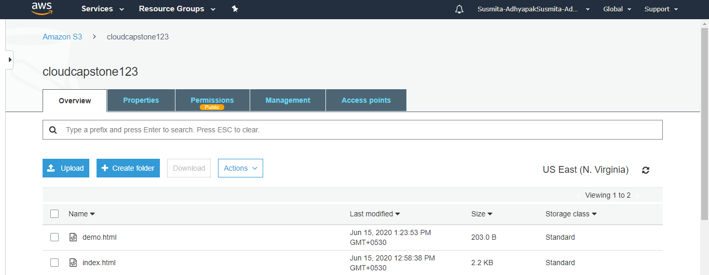

Step 10.3: Click on the newly uploaded file, and go to the Object URL

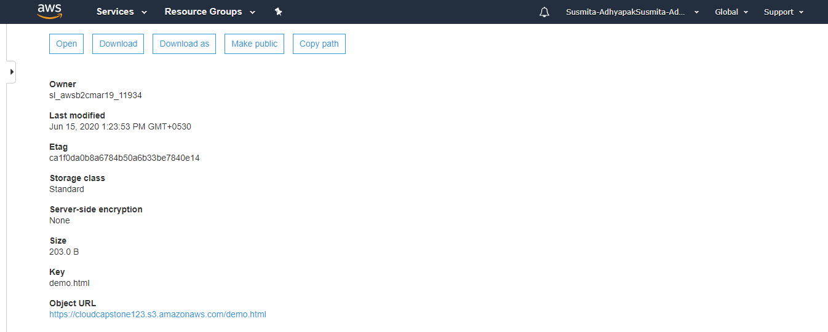

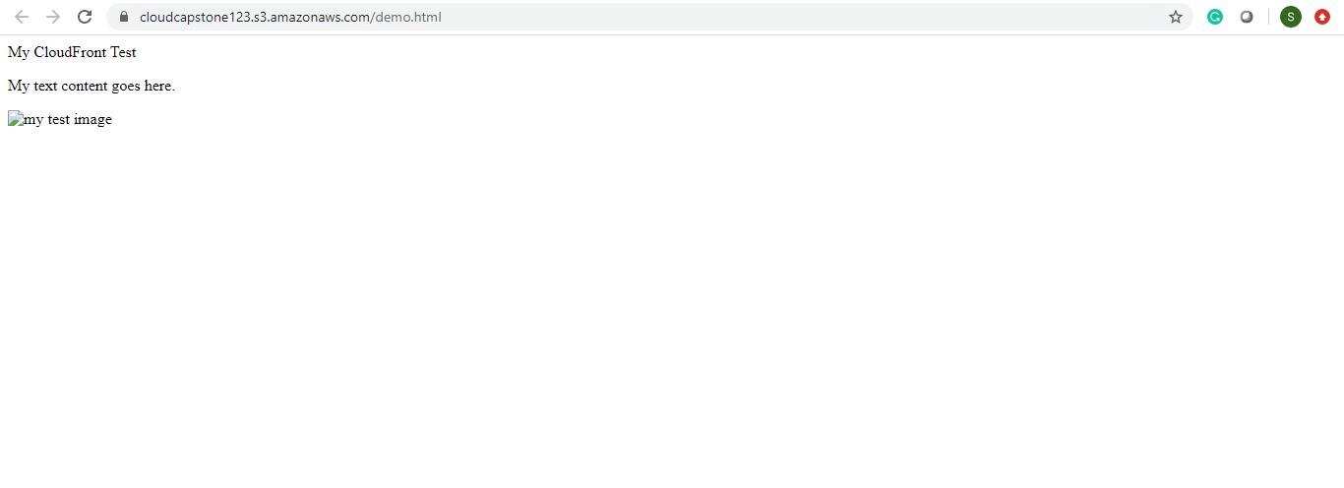

**Step 11:** Repeat steps 5 to 11 to create multiple deployments of your application in different regions so that you can meet the global traffic demand

**Step 12:** Use the traffic flow editor to create traffic policy to route traffic to different endpoints across the globe

**Step 13:** As good practice, follow the principle of least privilege so that you give access to the services that need to be accessed within the AWS console

**AWS:**

Approach 2:

**Step 1:** Log into the AWS console



**Step 2:** Before creating the resources, make sure you apply cost allocation tags to resources so that you can keep a track of billing later on

**Step 3:** To begin, create Route 53 and add a hosted zone if you have your own domain, this is an optional step to configure a custom domain for your web app

**Step 4:** Create an EC2 instance

Step 4.1: In the search window, search for EC2

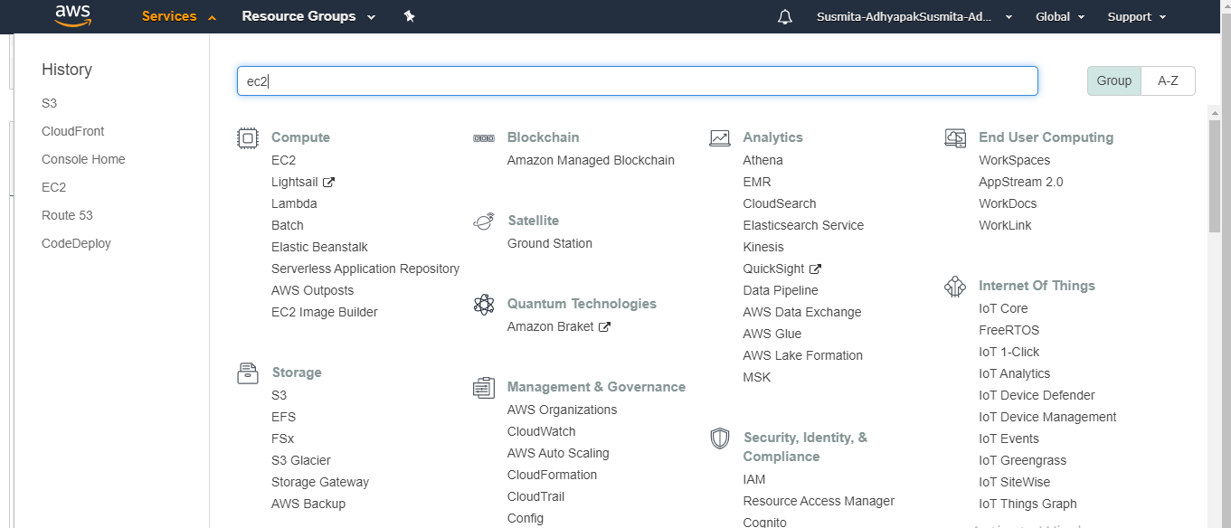

Step 4.2: In the EC2 instance, check whether a key-value pair is created or not. If not then create one

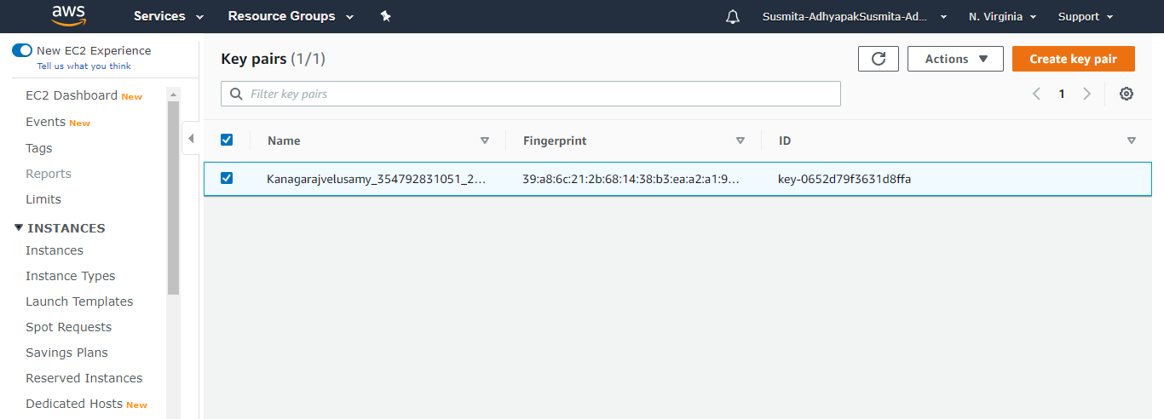

Step 4.3: Click on Launch instance

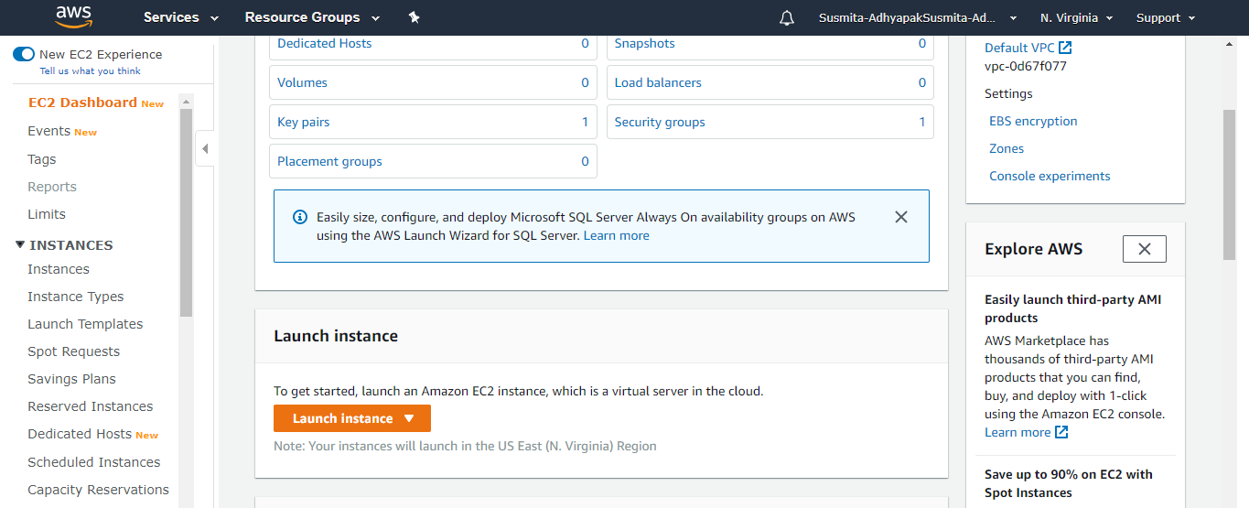

Step 4.4: Choose an Amazon Machine Image (AMI) (Free tier only) and click on **Select**

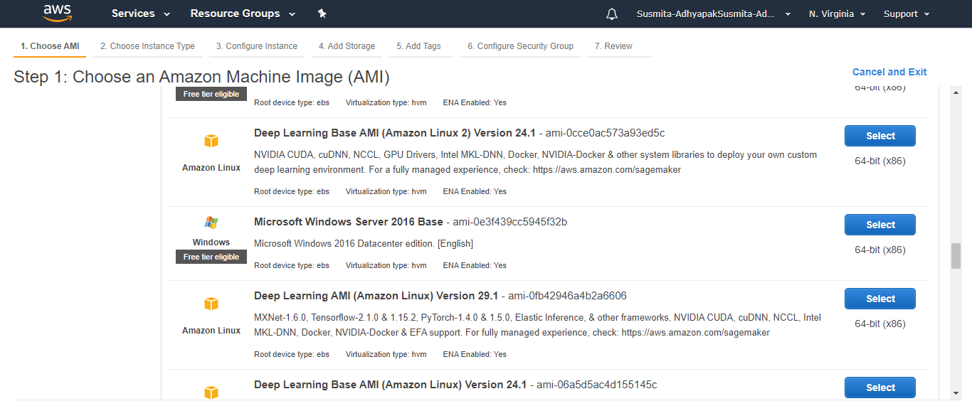

Step 4.5: Select a proper instance type (Select t2 micro) and click on **Next: Configure Instance Details**

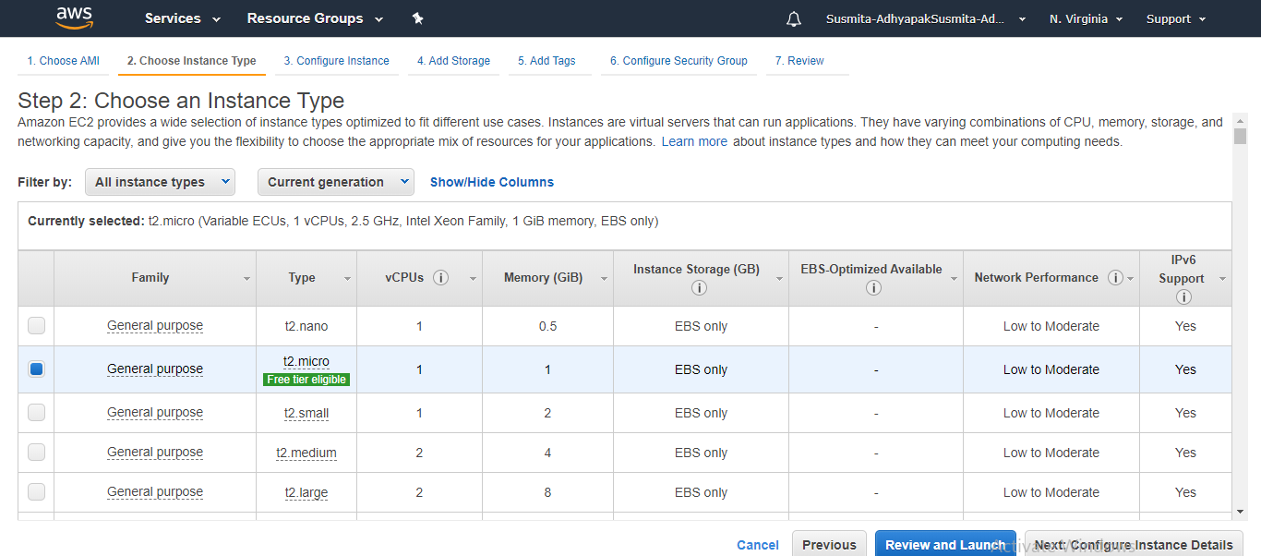

Step 4.6: In the EC2 dashboard, click on **Next: Add Storage**

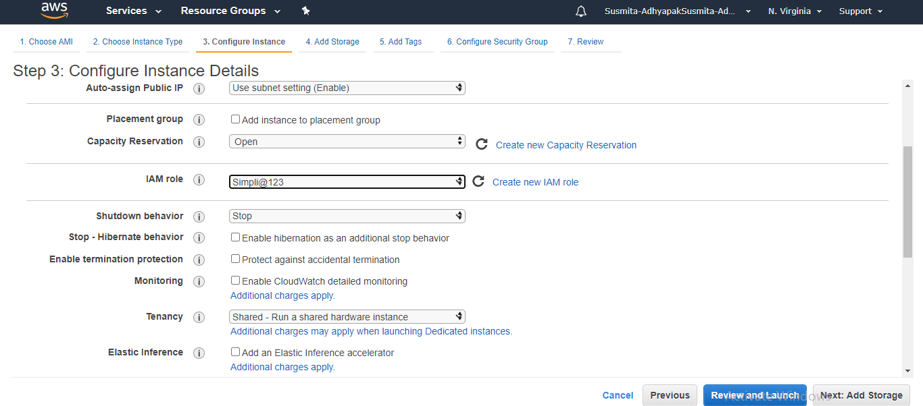

Step 4.7: Click on **Next: Add Tags**

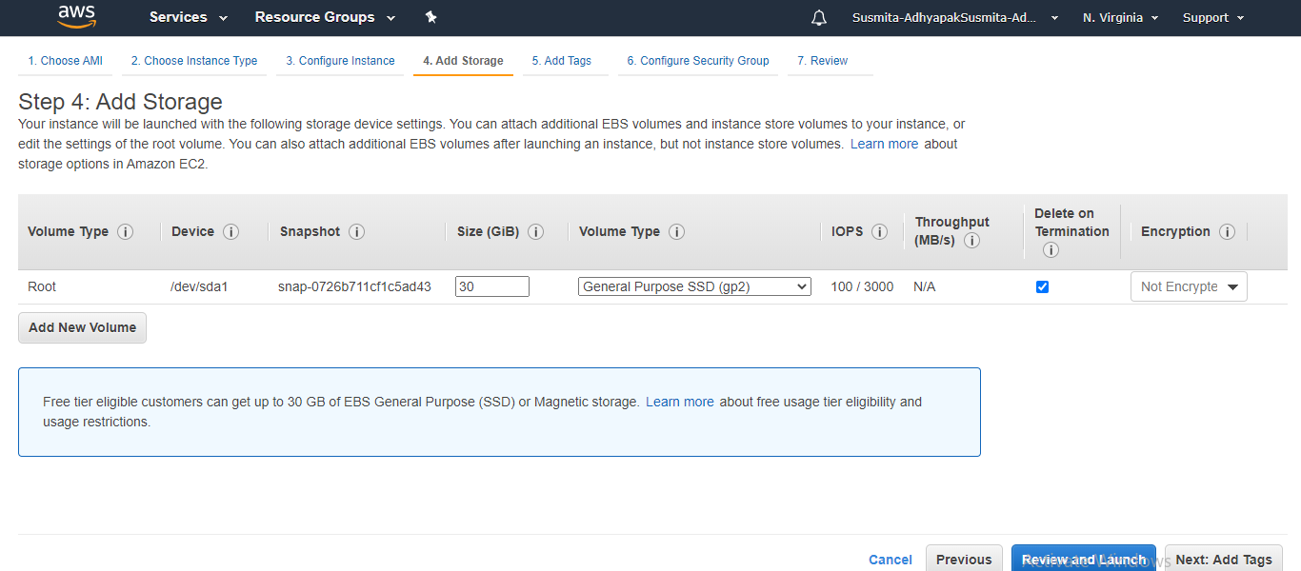

Step 4.8: Click on **Next: Configure Security Groups**

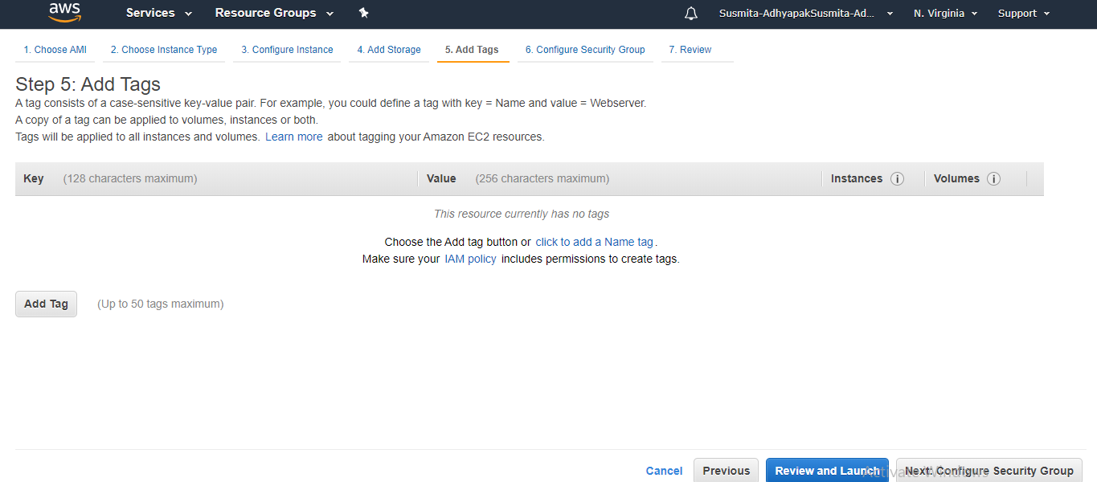

Step 4.9: Click on **Review and Launch**

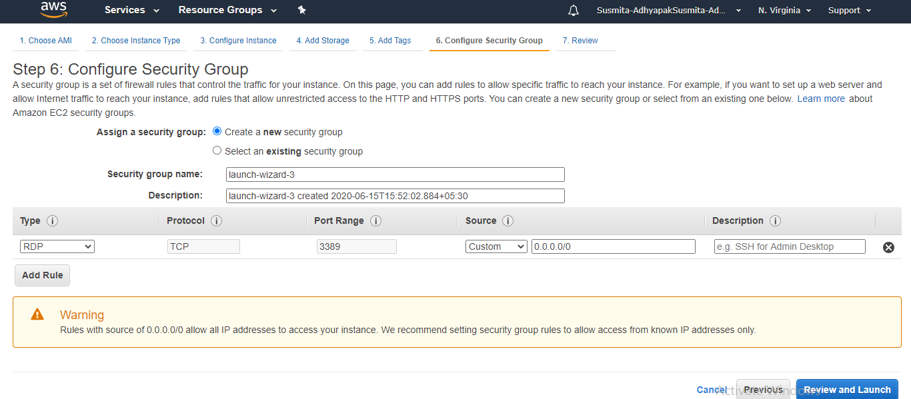

Step 4.10:Click on **Launch**

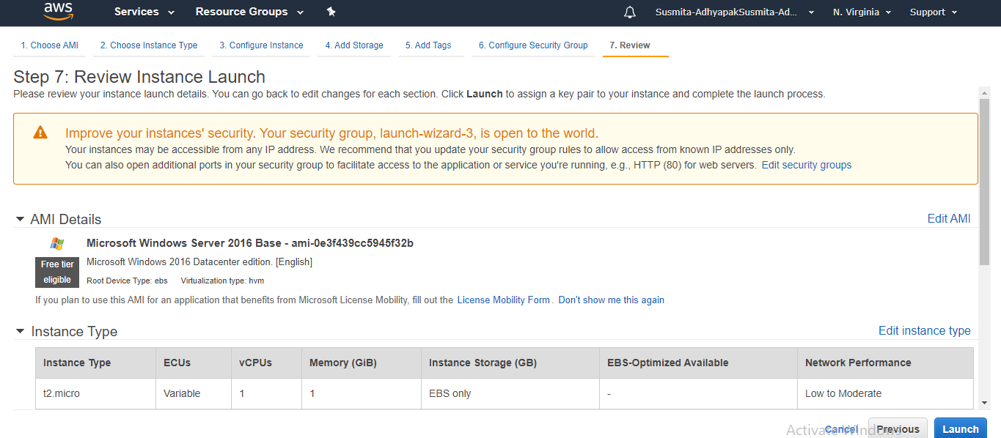

Step 4.11: Create a new key-pair, provide the name of the file and click on **Download Key Pair**

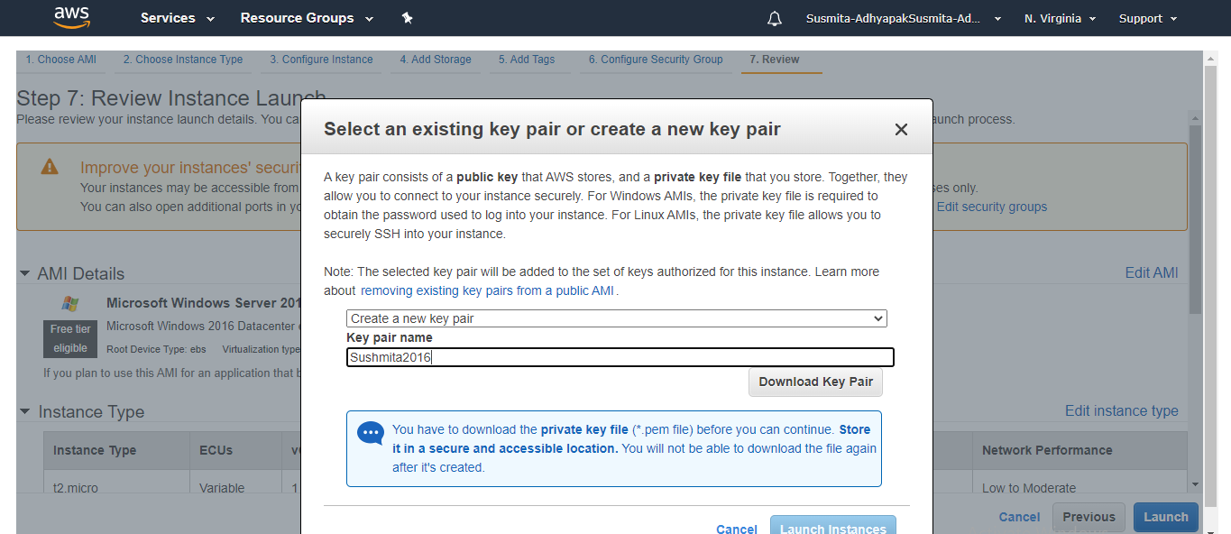

Step 4.12: Click on **Launch Instances**

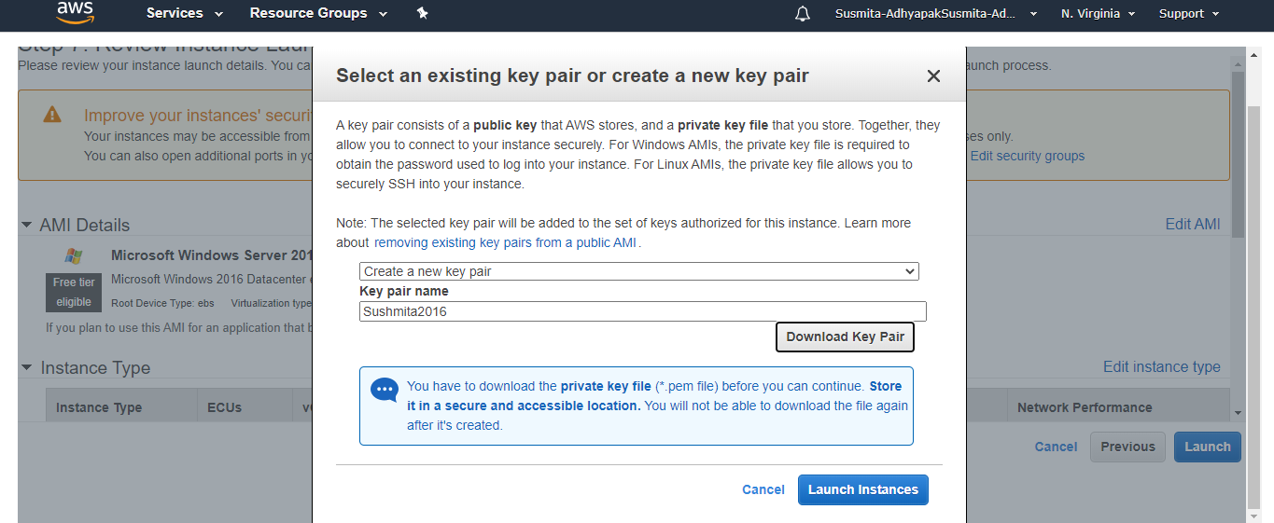

Step 4.13: Go to the EC2 dashboard, select the created EC2 instance and click on **Connect**

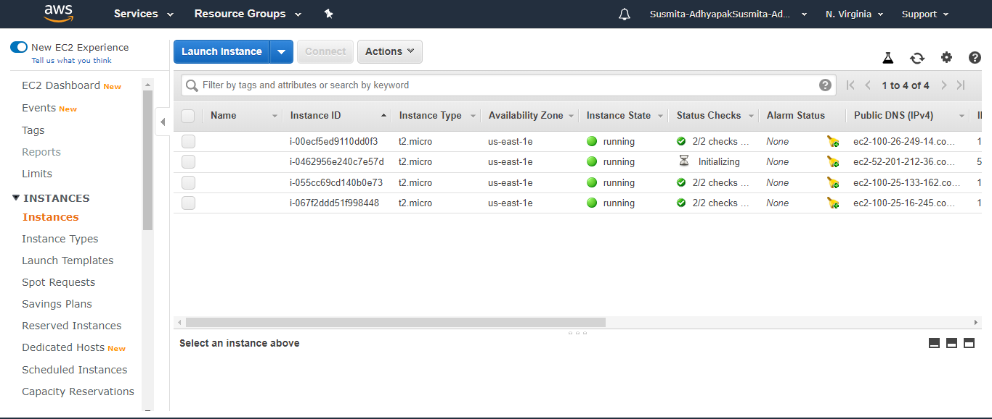

Step 4.14: Click on **Download Remote Desktop File**

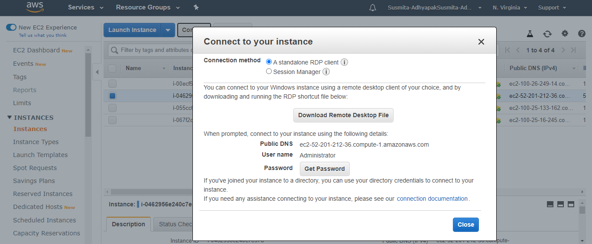

Step 4.15: Click on **Get Password**

Step 4.16: Browse to the Key Pair File you have downloaded using **Choose File** option

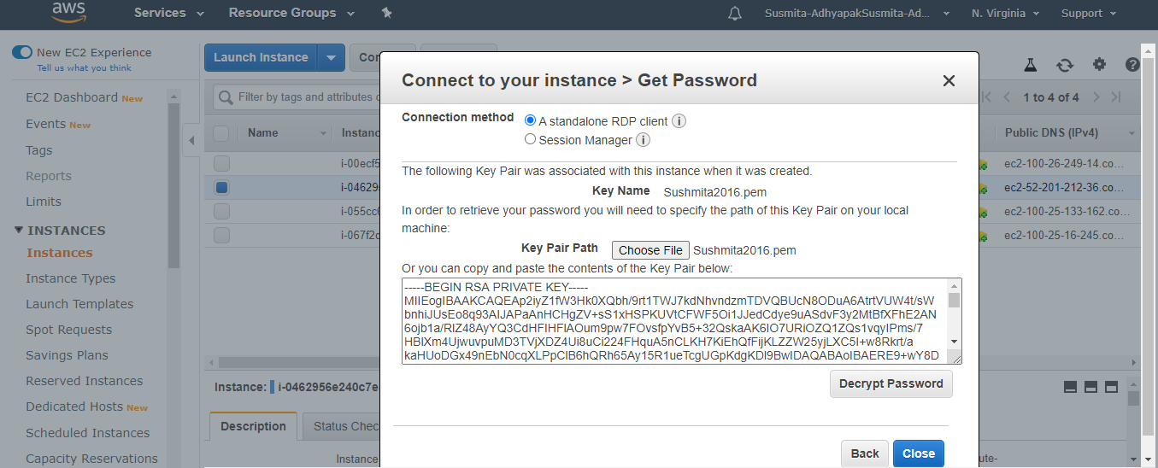

Step 4.17: Click on **Decrypt Password**

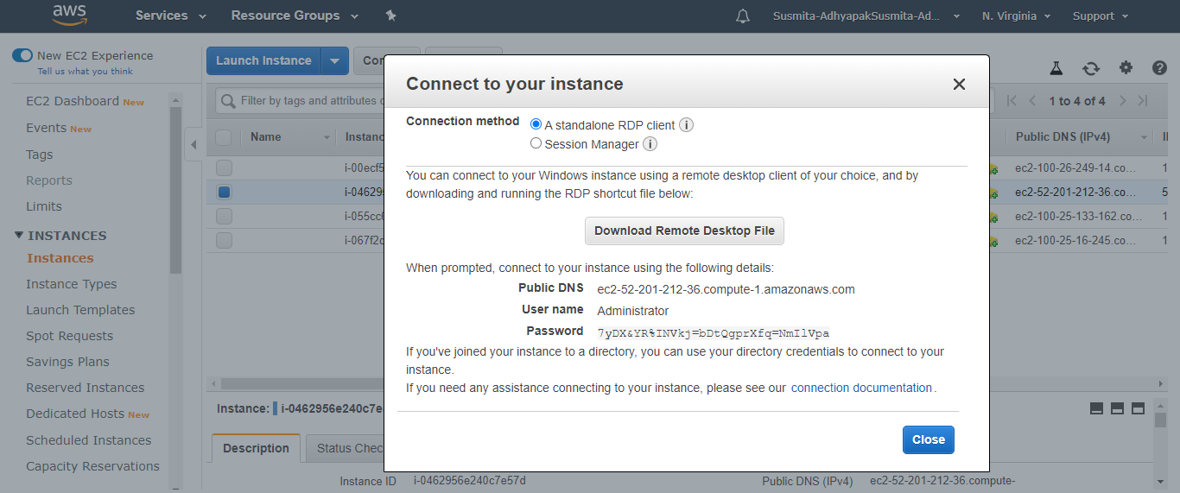

Step 4.18: Copy the decrypted password

**Step 5:** Make sure you have inbound traffic on port 80 and port 443 open

**Step 6:** Log into EC2 instance and spin up a web server of your choice on port 80

**Step 7:** Deploy your application on the web server that you have created within the virtual machine

**Step 8:** Hit the Public IP of EC2 instance (web app endpoint) to check if the application is online

**Step 9:** Now create a CloudFront distribution corresponding to the static web app endpoint.

Step 9.1: Go to services and search for CloudFront



Step 9.2: Click on **Create Distribution**



Step 9.3: Select a delivery method for your content as Web and click on Get Started



Step 9.4: Provide the Origin Domain Name (DNS name of the3 created EC2 instance) and Origin ID



Step 9.5: Keep all the values as default and click on **Create Distribution**



Step 9.6: These steps will create your CloudFront distribution.



**Step 10:** Configure the CloudFront distribution to point to your domain by editing the configuration and adding the domain name in Alternate Domain Name field

**Step 11:** Repeat steps 4 to 10 to create multiple deployments of your application in different regions so that you can meet the global traffic demand

**Step 12:** Use the traffic flow editor to create traffic policy to route traffic to different endpoints across the globe

**Step 13:** As good practice, follow the principle of least privilege so that you give access to the services that need to be accessed within the AWS console